

Best Practices for Migrating to Project Server 2007

Author:

QuantumPM, LLC

Date published:

April 2009

Summary:

This paper provides guidance, references and best practices to observe when migrating to Microsoft Office Project Server 2007 from Project Server 2003. The audiences for this guide are business application specialists, line-of-business specialists, IT generalists, program managers, and infrastructure specialists who want to migrate to Microsoft Office Project Server 2007 and want the required planning requirements, migration steps and helpful hints obtained from previous experience.

The information contained in this document represents the current view of Microsoft Corporation on the issues discussed as of the date of publication. Because Microsoft must respond to changing market conditions, it should not be interpreted to be a commitment on the part of Microsoft, and Microsoft cannot guarantee the accuracy of any information presented after the date of publication.

This white paper is for informational purposes only. MICROSOFT MAKES NO WARRANTIES, EXPRESS, IMPLIED OR STATUTORY, AS TO THE INFORMATION IN THIS DOCUMENT.

Complying with all applicable copyright laws is the responsibility of the user. Without limiting the rights under copyright, no part of this document may be reproduced, stored in or introduced into a retrieval system, or transmitted in any form or by any means (electronic, mechanical, photocopying, recording, or otherwise), or for any purpose, without the express written permission of Microsoft Corporation.

Microsoft may have patents, patent applications, trademarks, copyrights, or other intellectual property rights covering subject matter in this document. Except as expressly provided in any written license agreement from Microsoft, the furnishing of this document does not give you any license to these patents, trademarks, copyrights, or other intellectual property.

 2009 Microsoft Corporation. All rights reserved.

Microsoft, SQL Server, Windows, SharePoint, Active Directory, and the Office logo are either registered trademarks or trademarks of Microsoft Corporation in the United States and/or other countries.

The names of actual companies and products mentioned herein may be the trademarks of their respective owners.

Table of Contents

Introduction 1

Overview 1

Scope of this Guide 1

The Audience 1

Chapter Overview 1

Planning Your Migration Project 2

Envision Success for Your Business Goals 2

Reasons to Migrate 2

Business Goals 2

Technology Improvements 3

Use Public Resources 3

Microsoft Project Server 2007 Web Links 3

Use a Formal Schedule for Your Migration 6

Gold Certified Partners 7

Pick Your Team 7

Migration Team 7

End User Team 7

Analyze Project Server 2007 Features and Business Impacts 8

Conduct a Review of Project Server 2007 Architecture and Features 8

Evaluate Project Server 2007 Technology Features 8

Determine Business Process Impacts 13

Develop a Formal Project Plan for Your Migration 15

Scope Definition Statement 15

Roles and Responsibilities 16

Migration Sponsors 16

Risks, Issues, and Change Control 16

Communications Plan 16

Quality Test and Validation Plan 16

Schedule of Events 16

Performing Your Readiness Assessment 17

Perform Your Current State Business Process Assessment 17

Review Recent Use of Project Server 2003 17

Identify Custom Interfaces for Project Server 2003 18

Identify Custom Reports for Project Server 2003 18

Review the Project Server 2007 Platform Capabilities and Potential Uses 18

Prepare For Changes to Project and Resource Management 18

Project Scheduling and Project Web Access (PWA) Changes 18

Proposals and Activity Plans 19

Saved Links Not Available in Project Server 2007 19

Project Server 2003 Versions Not Available in Project Server 2007 19

Resource Management Changes 20

Resource Management Capabilities in Project Web Access 20

Resource Plans 20

Team Resources 20

Budget and Cost Resources 21

Status Report Migration Considerations 21

Preparing For Changes to Time and Task Update Processes 21

Differences Between Project Server 2003 and Project Server 2007 Timesheets 21

Project Server 2003 Administrative Plans versus Project Server 2007 Administrative Time 22

Project Server 2003 Historical Time Tracking Data 23

Planning For Timesheet Migration 23

Planning For Reporting Changes and Enhanced Capabilities 24

Project Professional 2007 Visual Reports 24

Project Web Access Data Analysis Views 24

SQL Server Reporting Services (SSRS) 25

Office SharePoint Server Excel Services 25

Planning and Preparing Your Technical Environment 25

Verify that computers meet hardware and software requirements 26

Confirm licensing and media 27

Confirm IT Staffing Availability and Training Needs 27

Install Project Server 2007 Environments 27

Analyzing and Cleansing Your Project Server 2003 Data 29

Perform Data Analysis to Determine Quality of the Data for Migration 29

Archive or Delete Project Schedules and Workspaces 29

Analyze Project Schedules 30

Validate Project Server 2003 Configuration Settings and Data 30

Validate Users and Resources 30

Validate Enterprise Global Custom Fields 31

Validate Security Templates, Groups, Categories 32

Validate Security Group and Category Members 32

Validate Views and the Associated Security Categories 32

Document the Pre-Migration Corrective Action Plan 32

Immediate Actions 32

Postponed Actions 33

Planning For The Migration Process and Contingencies 33

Pre-Migration Planning and Documentation Checklist 33

Pre-Migration Training 33

Pre-Migration Checklist 33

Server Information 33

Database Information 34

Migration Account Verification Information 34

Migration Tool and Project Server 2007 Version Verification 35

Perform data analysis on your existing Project Server 2003 data. 35

Run a Pre-Migration Verification Test 35

Data Analysis Queries and Corrective Actions 36

Contingency Planning 36

Perform a Test Migration 37

Performing the Migration and Post-Migration Activities 37

Pre-Migration 37

Update the Enterprise Global file to reflect new objectives and processes 37

Update or Re-engineer the RBS 37

Update or Re-engineer User Access and the Project Security Model 38

Perform a final Project Server 2003 data clean-up, verification and backup 38

Perform a final Windows SharePoint Services data clean-up, verification and backup 38

Migration 39

Prepare for the Migration 39

Enterprise Global Data Migration 39

Project Data Migration 40

Roll back Migration 40

Post-Migration 40

Preparing for Changes to Technical and Business Operational Policies 41

Project Server Technical Operations and Maintenance 42

Protecting Your Information Assets 42

Technical Operations and Maintenance Schedule 42

Project Server Applications Operations and Maintenance 45

Security 45

Enterprise Data 46

Enterprise Global 46

Timesheet Management 46

Reporting 46

Database Object Administration 47

Introduction

Overview

Your Project Server 2003 Enterprise Project Management (EPM) system represents a significant investment by your organization. You have probably implemented many EPM strategies including but not limited to:

* Business process and procedural guidance
* Technology installation and support
* Training and mentoring methods
* Accountability and reporting requirements,

You need to consider many factors as you determine the approach you should take to migrate your EPM environment from Project Server 2003 to Project Server 2007. Some of these factors affect your overall EPM vision for the immediate and long-term future so you should build a roadmap to migrate your EPM data.

Scope of this Guide

The purpose of this document is to provide you:

* Convenient best practice recommendations helping you to plan migration
* Reminders and considerations that will impact your migration planning and execution
* Cross-references to public domain information about migrating to Project Server 2007

Note: this document does not attempt to reproduce the content found within migration documents located on Microsoft’s sites (i.e., Office Online, TechNet, and MSDN). You should use those public sources to assist in planning and implementing your Project Server 2007 EPM system.

The Audience

The target audience for this guide is generally the following:

* Executive managers who want a high-level overview of the benefits and approach to migrating the Project Server system..
* EPM business managers who help determine operating processes and the future course for the EPM strategies.
* Technology leaders who will take actions to setup systems and move the Project Server 2003 data to Project Server 2007.
* Information technologists who are responsible for implementing and maintaining servers and systems.

Chapter Overview

The following provides a summary reference to the key sections found in this document:

* Planning Your Migration Project
* Performing Your Project Server 2007 Readiness Assessment
* Planning and Preparing Your Technical Environment
* Analyzing and Cleansing Your Project Server Data
* Planning For the Migration Process and Contingencies
* Performing the Migration and Post-Migration Activities
* Preparing for Changes to Technical and Business Operational Policies

Planning Your Migration Project

Envision Success for Your Business Goals

You should plan for your migration to Project Server 2007 migration with business goals and overall success in mind. How do you envision success for your migration? What aspects of the migration are important for you, your current Project Server user base and the leadership team?

If you begin with the endpoint in mind then you can identify the key outcomes for successful migration, such as:

* No loss of project or resource data.
* Minimal or no downtime for end users.
* All users able to successfully login and access their projects on Day One.
* Users are well versed in the new aspects of the tool so that they are productive following the migration.
* Your current and future EPM strategies prioritized and elaborated.

Reasons to Migrate

One of the most important questions you should address is: Why migrate from Project Server 2003 to Project Server 2007? The answer to this simple, yet insightful, question has two major components: business goals and technology improvements.

Business Goals

You have already established the need for EPM business processes and technology like Project Server 2003 so you must now ask and answer questions about why your organization should migrate to Project Server and Microsoft Office Project Professional 2007. Consider the following general statements as you contemplate justification for your Project Server 2007 migration:

* **Improve Productivity** – project and resource managers may need better overall productivity by improving the EPM software tools. Microsoft Project Professional 2007 has several additional productivity enhancements, the most important being multiple levels of edit undo/redo actions. Additionally, Microsoft Project Professional 2007 and Project Server 2007 architecture changes provide dramatic improvements for end-users who are located in remote worldwide locations.
* **Visibility to EPM Data** - Enhanced software tools help people advance their personal skills while supplying managers with better information about programs, projects, and resources. Microsoft Project Professional 2007 has improved Visual Reports features in addition to enhanced Project Web Access 2007 Data Analysis and other reporting views.
* **Enhanced Cost Planning and Tracking –** Microsoft Project Professional 2007 and Project Server 2007 have several enhancements that allow project managers to plan and track project-related costs like: travel expenses, contractor invoices, and other non-labor metrics.
* **Reduce Software Costs** – new Project Server features allow project managers to define and manage simple project schedules with Project Web Access, therefore reducing the overall number of Microsoft Project Professional 2007 licenses required.
* **Prepare for Future Releases** – Microsoft has indicated the next major release of Project Server and Microsoft Project Professional will have many advanced features that take greater advantage of SharePoint Products and Technologies collaborative features and technologies. Project Server 2007 is the natural starting point for the entire EPM community so you should move to Project Server 2007 well in advance of the future release.

Technology Improvements

Any Project Server 2007 system contains many advanced technology features that extend end-user functionality and also improve overall reliability.

* **Windows SharePoint Services** – Version 3.0 of Windows SharePoint Services is the backbone of Project Server 2007 thereby giving you a robust environment to customize the user interface to better meet your business requirements. You can customize Project Web Access appearance to suit your business needs and improve overall end-user productivity.
* **Logical Workflow** – Microsoft Office SharePoint Server and Windows SharePoint Services 3.0 have robust customizable workflow structures to guide people through the program, project, and document management steps required by your business requirements. Your organization can codify business processes into workflows that help ensure people are taking the right actions.
* **Webparts** – are powerful webpage applications that connect to and present data from various system databases. Office SharePoint Server, Windows SharePoint Services, and Project Server 2007 provide a robust extended set of application functions to present EPM data like: project schedules, resource workloads, program and project costs, timesheets, artifact documents, risks/issues/deliverables, etc.
* **Advanced Reporting** – PWA views and customizable options allow managers to get better information about projects and resources. Office SharePoint Server extensions also enable convenient reporting tools like Excel Services.
* **Productivity Automation** – is dramatically enhanced through Project Server Interface (PSI) software functions that allow you to leverage logical workflows that were very difficult within Project Server 2003.

Use Public Resources

There are many public references that provide a variety of help as you consider migrating from Project Server 2003 to Project Server 2007. Microsoft has published documentation and articles that help you understand the technical aspects of migration.

Microsoft Project Server 2007 Web Links

Project Server 2007

You can visit the Microsoft Office 2007 Online website and use the Products tab to find a link to Project Server 2007.

<http://office.microsoft.com/en-us/products/FX100487411033.aspx?pid=CL100571081033>



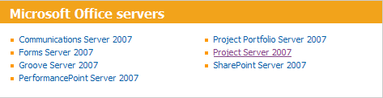

Bookmark the following link for more information about the Project Server 2007 software suite and additional information.

<http://office.microsoft.com/en-us/projectserver/FX100739841033.aspx>



Select the Frequently Asked Questions (FAQs) link to find TechNet articles about Project Server 2007. The Deployment subsection contains a link to migration whitepapers and technical guides that are located within the TechNet sites.

<http://office.microsoft.com/en-us/projectserver/HA102053431033.aspx?pid=CL100629881033>

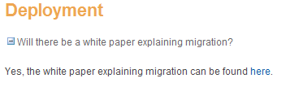

<http://technet.microsoft.com/en-us/library/cc197720.aspx>

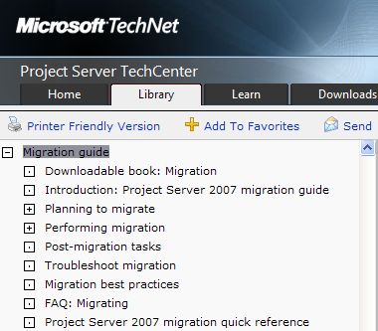

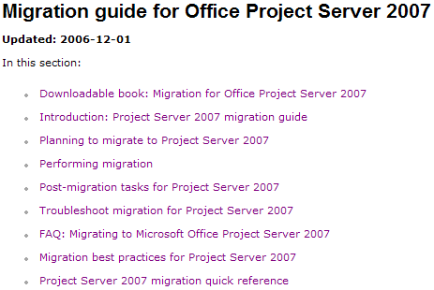

* The “Downloadable book…” link allows you to save an extensive Word document containing detailed technical considerations for migrating from previous versions of Project Server.
* “Introduction…” gives you an overview of migrating to Project Server 2007 including special notes about Windows SharePoint Services and SQL Server.
* “Planning to migrate…” provides additional links describing migration scenarios, server deployment options, Project Server cross-version compatibility, data that is not migrated (including important caveats), and migrating from older version of Project Server.
* “Performing migration” includes several important links like: preparing for migration, cleanup your data, configuring and using the migration tool, upgrading Windows SharePoint Services workspaces, and basic information about scaling servers.
* “Post-migration...” has additional links to: verifying migration worked, updating server settings, synchronizing forms-authenticated users, verifying project workspace provisioning, deleting inactive users, correcting currency settings, altering local Windows accounts, and updating multi-language lookup tables.
* “Troubleshooting…” contains articles like: before you troubleshoot, error logging, restoring databases, user permission and authentication issues, and migration flowchart.
* “FAQ…” contains several common questions and answers about migrating issues like: compatibility, data consolidation from multiple Project Server 2003 instances, pricing and licensing, data consistency (master and sub-projects, versions, etc.), protected actual work, multi-language, resource management, etc.
* “Migration best practices…” provides a brief description of activities: before, during, and after migration.
* “… quick reference” is a shortlist summary of migration actions.

Project Server Feature Comparison List

Microsoft has posted a very nice feature comparison list at the following website:

<http://office.microsoft.com/en-us/projectserver/FX101759381033.aspx>

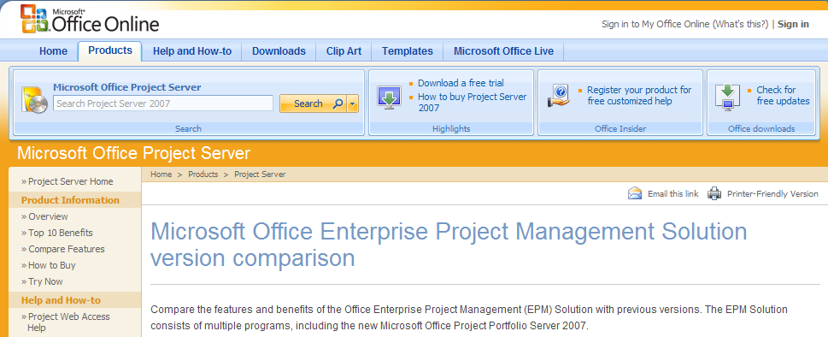

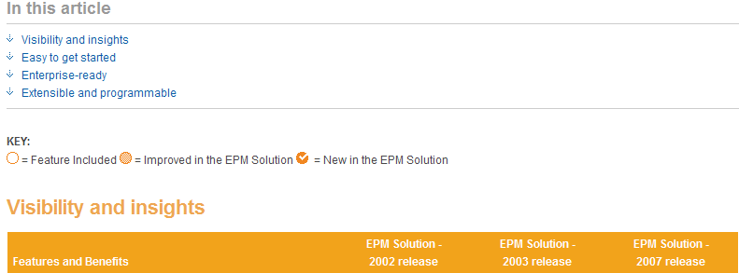

Use a Formal Schedule for Your Migration

Consider using the Microsoft Project Professional 2007 schedule at the following Microsoft website as the basis for your migration schedule. This template also contains many helpful “Notes” for key tasks throughout the schedule timeline.

<http://office.microsoft.com/search/redir.aspx?assetid=TC102763291033&QueryID=bJ-FF3H0N&respos=1&rt=2&pid=CT102530621033>

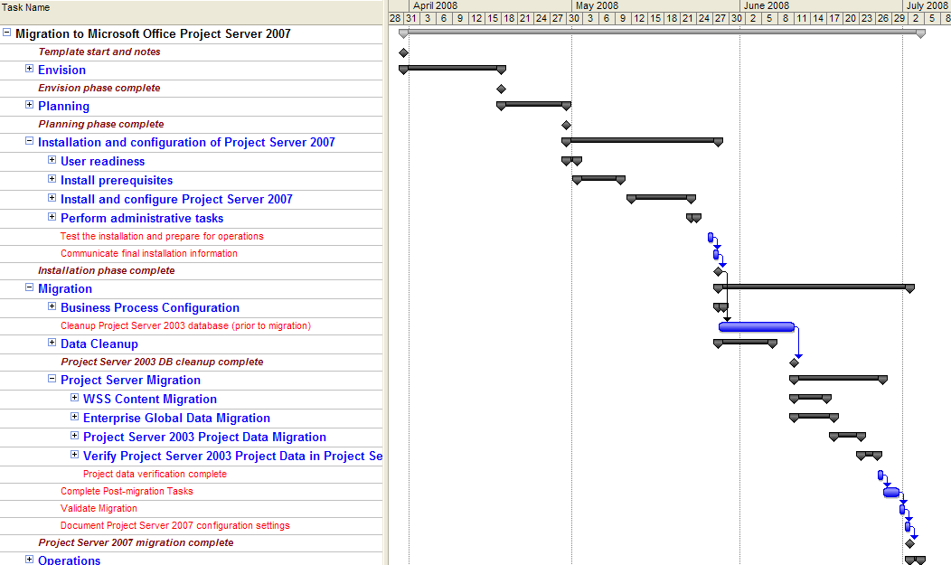

Gold Certified Partners

Microsoft has certified several partner companies as experts for EPM deployments and system migrations. You can find partners on the Microsoft web site by searching for EPM solution provides at: <http://www.microsoft.com/solutionfinder/Marketplace/Home.aspx>.

Pick Your Team

Migration Team

You should identify the people who will responsible for planning and performing the migration. The typical roles that are involved in a migration project include:

**Migration Project Manager -** This role should be performed by an experienced Project Manager who will be responsible for planning the work, scheduling the activities and coordinating the plans and resources with key functional leaders (e.g., IT, PMO, business users).

**Migration Lead -** This role should be performed by an experienced EPM technical/functional architect who is knowledgeable with Project Server 2003 and Project Server 2007 as well as the organization’s project management processes. This person will participate in all aspects of the planning and risk management and will determine how to address unforeseen events.

**Migration Technical Resource -** This role should be performed by one or more technical resources who are familiar with or can learn the installation and technical administration aspects of both Project Server 2003 and Project Server 2007. This resource will perform and validate the technical installation and, in many cases, will perform the technical migration processes. This role is also sometimes called “IT Professional (ITPro)”.

**Migration Trainer –** This role will be responsible for creating or updating user documentation and specific training manuals as well as training end users in the new features of Project Professional 2007 and Project Server 2007. In most instances, you will want to have role-based training to streamline learning for specific responsibilities (e.g., Project Manager, Resource Manager, Team Member).

**Server Administrator –** This role is responsible for maintaining the server systems on a day-to-day basis.

**IT Coordinator(s) –** This role is the key point of contact for IT department functions and makes plans and carries out commitments for IT implementation tasks.

End User Team

You should identify a subset of end users who can provide input and feedback to the decisions that impact your migration approach and changes to your business processes based on new or changed design features in Project Server 2007. The people on this team should have the authority to make key decisions for data to be migrated and usage of the system. It is recommended that you keep the End User Team to a manageable size with broad cross-organizational representation of the current usage of the existing Project Server 2003 environment. The typical End User Team roles that are involved in a migration project include:

**PMO / Project Manager Lead –** is the person who leads the Project Managers and has authority to make decisions for how other Project Managers will use the system. This person is involved in all aspects of the planning and execution of tasks that involve Project Managers.

**Project Managers -** represent a cross-section of the project managers who plan projects and track progress by maintaining project schedules.

**Resource Managers -** represent the people who allocate resources to projects and who may approve time submitted by individuals for both project and administrative activities (working and non-working time).

**Project Users / Team Members –**are the users who are assigned tasks, report time and update status on assigned tasks. They may also be responsible for creating or updating issues, risks and/or deliverables on projects.

**Project Server Administrators –** are those individuals who are trained to use the various PWA configuration and control features. They are responsible for modifying and maintaining general settings of the EPM application like: enterprise global codes, PWA views, Microsoft Project Professional 2007 global settings, etc.

Analyze Project Server 2007 Features and Business Impacts

Conduct a Review of Project Server 2007 Architecture and Features

Many new architecture and application features have been introduced with Project Server 2007 that will have an impact on the way the end user community performs its work. Some Project Server 2007 features affect overall server performance and improve end-user productivity. Other features are completely new compared to Project Server 2003, so you need to understand how these features work and how your organization will benefit if you decide to use these new features.

You should generally consider two major subsections within your analysis: technology features and business process impacts. You may want to make a list of the major Project Server 2007 technical features so you can determine the specific associated business process impacts to your organization. Microsoft has provided many public websites with information about Project Server 2007 and how to plan the installation of this technology. These details are beyond the scope of this document; however, you can find this information at the following link: <http://technet.microsoft.com/en-us/library/cc303399.aspx>

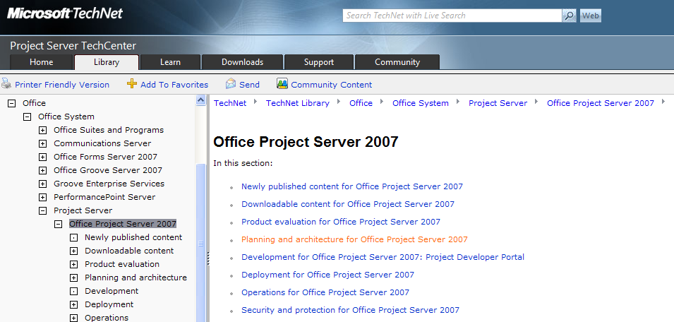

Evaluate Project Server 2007 Technology Features

You need to make decisions regarding which of the new features will be used and how they will impact the migration plan. You should identify specific features that will be used immediately or postponed until after the migration. These features may include but are not limited to:

* Microsoft Project Professional 2007 functions
* Timesheets
* Task Updates
* Administrative Time
* Timesheet periods and protected actual work
* Proposals / Activity Plans
* Resource Plans
* Deliverables
* Improvements in Reporting (OLAP and SQL Reporting Services)

The major changes to Project Server 2007 technology will have a large impact on the way you purchase, install, and configure this advanced EPM system. The following sections are intended to provide best practices and tips that require your special attention as you consider the scope of your migration.

Windows SharePoint Services Architecture

The Project Server 2003 Project Web Access functions had certain limits to the ways you could customize the presentation to the end-users. Project Server 2007 uses powerful Windows SharePoint Services capabilities that allow you to customize the appearance of the Project Web Access interface presented to the end-user community. You can define a presentation schema that helps people quickly find information within the PWA pages by altering conditions like graphic logos, color theme and icon images. This also allows you to establish presentation and navigation design that is consistent with other websites across your organization. Consider the following important functional differences between Project Server 2003 and 2007 functionality:

* Use color themes to distinguish between various Project Server 2007 instances: Development, Training, Production, organization-specific Project Server instances, etc. The color themes can help people quickly identify which Project Server instance they are using.
* Position graphic symbols and logos on the PWA pages so you can establish desired branding appearance consistent with your organization standards.
* Web Parts now play a big part in the overall functionality and presentation of PWA 2007. You can place registered Webparts on pages so users can access a large array of data from within the PWA presentation environment.
* You can register and use various Windows SharePoint Services templates to present different appearances and content associated with project schedule workspaces. These templates can include configuration settings like: color themes, graphics, Webparts, internal/external hyperlinks, customized lists, and predefined document templates.
* Microsoft Office SharePoint Server extends core Windows SharePoint Services capabilities including: Excel Services, InfoPath Form Services, Business Data Catalog, workflow logic, and expanded search capabilities.

SQL Databases

Project Server 2007 uses a completely different database design and schema than was used for Project Server 2003. The new architecture enables you to partition server systems and actions to maximize performance. You need to consider these conditions because they have important ramifications to the overall performance and implementation across a broad user community who may be located in various parts of the world. Consider the following:

* You may have reporting batch or live processing that requires intense data access to the Reporting database. You may want to place this database on a server that is designated for this type of compute load.
* Windows SharePoint Services stores and manages project-level workspace sites and associated content within SQL databases. You may decide to place one or more Content databases on different servers that are managed according to your organization level of services agreements.

Queue, Event, and PSI Processing

Project Server 2007 has a new architecture that changes the way certain system features and functions behave. The Queue and Event processing components control many of the general processing functions like: project schedule publishing, resource assignment notification, timesheet collection and processing, OLAP cube processing, and Windows SharePoint Services workspace provisioning with security updates. You need to understand these processes so you can make informed decisions about how your server processing will be structured to maximize end-user throughput.

The Project Server 2007 Queue processing controls will have a dramatic impact on remote users who may have been using Terminal Server or Citrix methods for connections to Project Server 2003. Some of your end-users may have been using Microsoft Project Professional 2003 and HTTPS connections to open and save project schedules across the internet. The Project Server 2003 performance level may have caused long wait times for project save and publish actions. Project Server 2007 Queuing mechanism allows remote users to directly access project and resource data from their desktops, without having to use Terminal Services to help the end user experience. The performance improvements will have a dramatic impact on end-user productivity in addition to reducing the number of Terminal Server and Citrix software use licenses.

You may have an internal software development group or use the services of a software provider to intercept Project Server 2007 processing and perform some customized software actions. The Project Server 2007 Event processing architecture enables you to perform this type of special processing for actions like: update remote databases, import remote data from legacy systems, and snapshot data for later batch processing.

The Project Server Interface (PSI) software interface is dramatically expanded compared to the Project Server 2003 Project Data Services (PDS) functions. This gives your organization high flexibility to automate many common program, project, and resource actions that were typically performed using manual methods within Project Server 2003.

Microsoft Project Professional 2007 Cache Processing

Microsoft Project Professional 2007 uses a new architecture and communications method to save and retrieve project schedule and resource information stored within the Project Server 2007 databases. Microsoft Project cache processing now uses a strategy that transfers larger blocks of data between the end-user and Project Server 2007. This mechanism releases Microsoft Project menu functions so the end-user can continue activities without waiting for Microsoft Project to finish data transfer.

Project Server 2007 also manages synchronizing data transfer between end-user Microsoft Project applications. Each user has a local cache containing their copy of specific projects they have edited. This leads to the possibility that multiple users edit schedule details with the potential for multiple old schedules in process. This situation is handled since Project Server 2007 and Microsoft Project Professional 2007 automatically communicate to ensure only the latest saved project schedule is opened, even if the user attempts to open a project from their personal cache.

This local caching mechanism is managed in association with Project Server 2007 Queuing mechanisms therefore providing superior data transfer throughput that enhances local or remote end-user productivity. You will need to provide your end-user community and Project Server administrators information that helps them understand this mechanism and how to troubleshoot processing issues.

ActiveX Web Controls

Project Server 2003 architecture had basic assumptions about download and registration of ActiveX components used by Project Web Access. This architecture is now redesigned within Project Server 2007 system so you need to make decisions about how these components are installed on the end-user computers. You may be using computer-level security lockdown conditions that prevent the end-user from installing and registering certain features like ActiveX component. Therefore you will need to determine how these ActiveX features are distributed to your world-wide user community. Please see: <http://blogs.msdn.com/chrisfie/archive/2008/11/13/microsoft-project-server-and-portfolio-server-2007-activex-controls.aspx> for a link to the latest Active X Controls.

Microsoft Project Professional 2007 Features

Microsoft Project Professional contains several changes that your project schedulers will need to understand. Consider the advantage and impact of the following popular revised or additional features:

* Multiple undo/redo actions allow users to correct mistakes or perform what-if analysis.
* Change highlighting visually marks task-level data fields that change as a result of an edit change like: duration, work, constraints, changes that impact task dates, etc.
* New cost resources allow project managers to better manage typical cost items like: vendor invoices, purchase orders, etc.
* New budget resources allow project managers to model overall project budgets for conditions like: work effort, capital vs. expense costs, material utilization, etc.
* Visual reports allow project managers to extract schedule metric and export to Excel or Visio.
* Task-level flags indicating if a task should appear or be removed from team member timesheets.
* Expanded and improved online help including access to Microsoft global online market and blogs.
* A new resource type called Teams that allow resource and project managers to postpone assigning individual people to tasks. This feature also allows Team Leads or Team members to volunteer for task-level assignments on behalf the general team.
* Changes to master and subproject processing improve managing groups of related projects, also sometimes called programs.

Project Web Access 2007 Features

Several changes or extensions to PWA are notable for your consideration:

* Data displays are presented by various Project Server 2007 registered Webparts that can be placed on most PWA pages.
* The Project Center can now display more data columns, expanding previous display limits that existed in Project Server 2003.
* Project Center and Resource Center item properties have been restructured and expanded.
* A new Proposals and Activities function allows project managers to create and manage project schedules using a PWA interface, thereby eliminating the need to use Microsoft Project Professional for certain types of projects.
* A new Resource Plan method allows managers to predict resource utilization requirements for projects.
* The timesheet collection and schedule update functions have been revised compared to similar functions in Project Server 2003. These new features also contain improved record history logs that can be used for auditing purposes. Additionally, there is an optional timesheet approval workflow and reviewing function that can be enabled thereby allowing resource managers to approve or reject timesheet data before it is sent to project managers for schedule updates.
* New features are added to define and collect non-project, also called administrative, time that can be labeled with finance and accounting codes for improved data exchange.
* Enterprise global customized fields have been completely redesigned thereby allowing you greater flexibility to define attributes for: projects, resources, and tasks. These fields also have improved graphical indicator controls and display.
* OLAP cube rebuild performance has been dramatically improved and cube data expanded to contain time-phased and non-time-phased data, thereby reducing the need to use customized OLAP extension functions typically found in Project Server 2003. OLAP cube data and associated Data Analysis views also now include Windows SharePoint Services risk and issue data so you can review resource-level responsibilities.
* New Project Server administration functions enable expanded and improved controls. Notable controls include: improved security, more flexible enterprise global definitions, OLAP cube settings with extensions, definition of fiscal year periods, queuing system management, and Windows SharePoint Services provisioning.
* Project Server Interface (PSI) now replaces Project Server 2003 Project Data Services (PDS) with expanded functionality and controls. These new functions enable more robust automation and workflow controls. For more information on developing for the Microsoft Office Project products and environment, see the MSDN Developer Center for Project Developers at <http://msdn.microsoft.com/en-us/office/aa905469.aspx>.

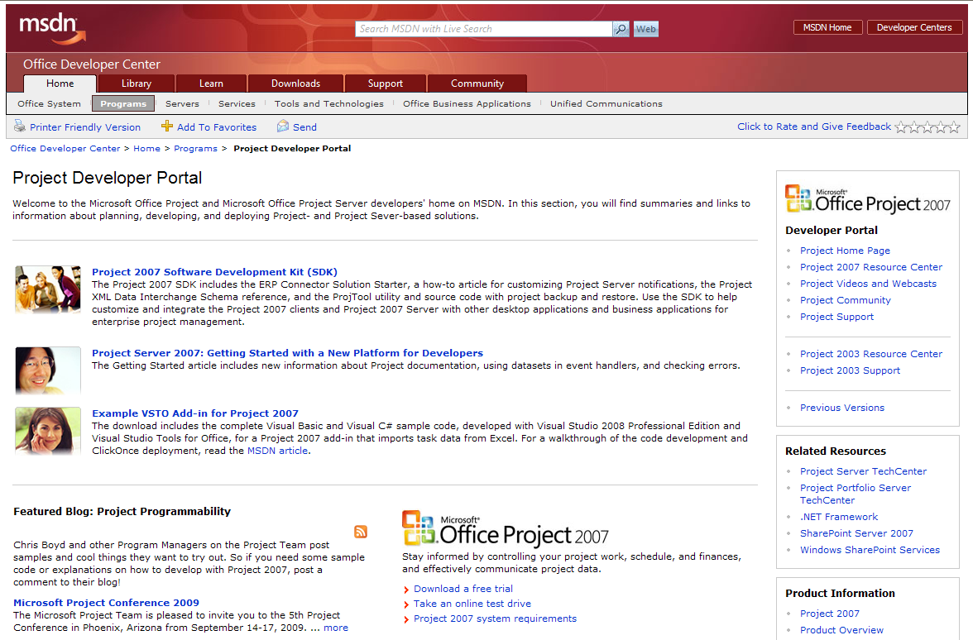

For specific information on the PSI, go to: <http://msdn.microsoft.com/en-us/library/ms457477.aspx>

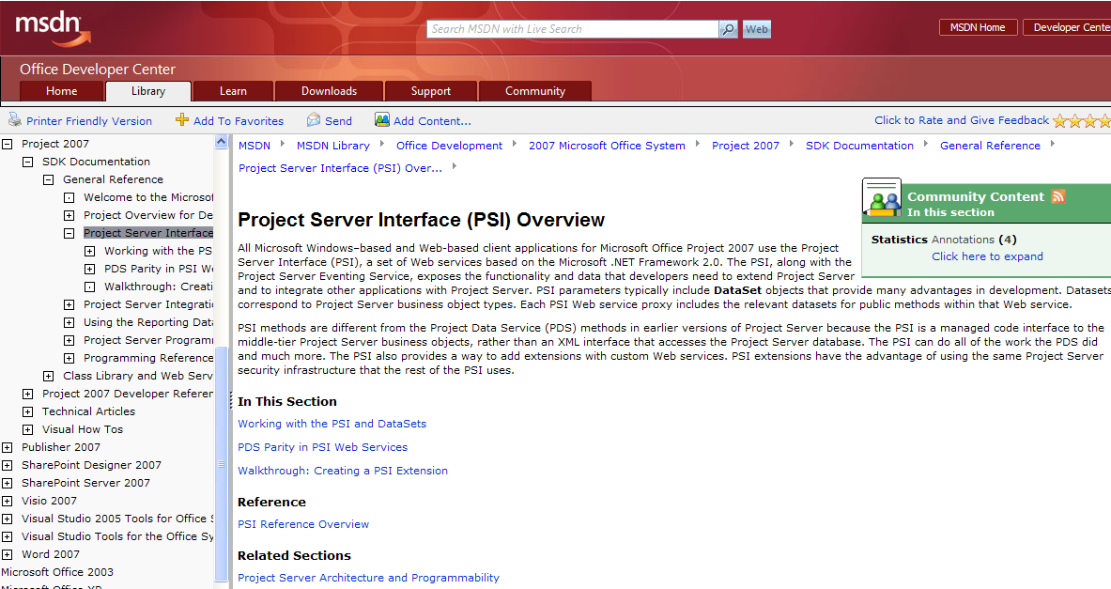

Determine Business Process Impacts

Migrating to Project Server 2007 will probably also impact your current business processes and procedural guidance. You should consider improvements and revisions to previous methods to leverage new Project Server 2007 technology and also advance your organizational EPM maturity. Consider the following important business processes that are linked to a successful migration to Project Server 2007:

Project Management

You may need to address the following typical project management processes and procedures:

* defining and assigning project- and task-level custom attributes
* defining project-level budgets then tracking effort and costs compared to baseline predictions
* updating schedule conditions like: actual and remaining work, accrued costs, vendor invoices, consumable materials
* assigning resources like: teams, generic roles, generic budget and cost, individual people
* activating and deactivating task-level resource assignments
* managing risks, issues, action items, and artifact documents.

Resource Management

You may need to address the following typical resource management processes and procedures:

* defining and assigning custom resource attributes
* activating and deactivating resources
* analyzing and correcting overall resource workload conditions
* reviewing and approving timesheet and task-level schedule updates
* auditing resource performance including: actual vs. baseline work, completion of assigned risks/issues/deliverables.

Management Reports

Project Server 2007 now contains a striking expansion to OLAP cube data thereby bolstering new Data Analysis views compared to Project Server 2003 Portfolio Analyzer viewing functions. The Project Server 2007 Reporting database also contains helpful data and views that enable more robust SQL Server Reporting Services (SSRS) display generation. Consider the following typical reporting business process changes:

* OLAP cubes now contain several sub-cubes including: resource assignments, Windows SharePoint Services deliverable/risks/issues, time-phased project and task details, time-phased resource details, and timesheets. Data Analysis views can take advantage of these cubes so managers can interact with the data by using Excel pivot tables and charts.
* Database details are different compared to Project Server 2003 so all customized SSRS reports should be redesigned and restructured. You may even consider eliminating some of the custom reports and using default Data Analysis views as an alternative.
* You may want to consider advanced dashboard display mechanisms that were not practical for Project Server 2003. These dashboards may contain features like: customized Webparts that connect to other data systems, SSRS display panels that use .NET functions to consolidate data, and Office SharePoint Server Excel Services. Some dashboard designs can also provide data edit and update actions you provide to make it easier for people to change data conditions.

Time Collection and Schedule Updates

Project Server 2007 timesheet and task update functions are completely redesigned compared to Project Server 2003 functions. There are several business process and procedural changes you must consider as you determine migration scope. Consider the following questions:

* What level of detail is good enough for your business purposes? The answer will affect expectations for roles like: project managers, resource managers, team leads, team members, accounting, etc. Your business requirement will also drive overall organizational behavior to: make a note of, record, and post actual work effort progress to scheduled tasks.
* What is your organizational timesheet collection and schedule update frequency? The answer has direct impact on organizational behavior and also has important effects on server hardware and software performance.

Role-based Training

The Project Server 2007 and Microsoft Project Professional 2007 technical features are significantly different compared to Project Server 2003. The business processes and detailed procedures you employed in Project Server 2003 will also be revised as suggested above. Now you must consider training requirements so your people can use the system effectively. You should consider providing role-based training like:

* **Executives** – must understand how to interpret the Project Server data so they can drive organizational behavior
* **Program and Project Managers** - have many new or revised features to understand within the context of redesigned business processes.
* **Resource Managers** – must understand timesheet and workload management strategies.
* **Team Leads** – may be required to reassign task assignments to team members who are accountable to deliver completed project artifacts.
* **Team Members** – need instruction regarding what kind of timesheet and progress status is required and how often they should provide this information.
* **Project Management Organization (PMO)** – must understand how Project Server 2007 technology features are used within the context of business processes, procedures, and goals.
* **Project Server Administrators** – need full training to understand how to configure and maintain Project Server and Office SharePoint Server settings and operational health.

Develop a Formal Project Plan for Your Migration

You should define a formal project plan document, usually a Microsoft Word document, which contains important content sections like:

* **Scope Definition Statement –** establish limits for your migration,
* **Migration Sponsors –** state who are the overall sponsors and their individual interests as they fund the migration,
* **Roles and Responsibilities –** declare who are the key contacts during the migration,
* **Risks, Issues, and Change Control –** describe how you intend to record and manage inevitable conditions that can impact the migration,
* **Communications Plan –** include a statement of how you will communicate initial, ongoing, and final results of the migration,
* **Quality Test and Validation Plan –** describe the formal approach you will take to test and validate the migrated data and revised system configurations,
* **Schedule of Events –** show a high-level timeline of key migration activities and milestones.

**Note:** use the migration project plan document to seek formal management approval to authorize a range of work activities and costs associated with the migration.

The following sections provide you with additional information about each of these important items.

Scope Definition Statement

This section of the project plan document contains a clear description of activities and deliverables that are included and also excluded from your migration to Project Server 2007.

* Set overall expectation of major details that are addressed before, during, and after migration,
* Create statements declaring assumptions, exclusions, and business benefits,
* Create a Work Breakdown Structure (WBS) that declares major work package deliverables. There are several books and references available on developing Work Breakdown structures including standards from ANSI (ANSI/EIA Standard 748-A for WBS development and Earned Value Management) and the Project Management Institute (PMI – Practice Standard for Work Breakdown Structures).
* Establish major boundary limits for features and content deliverables like: full vs. partial project migration, Windows SharePoint Services workspace migration with style template changes, server hardware and software acquisition, single or multiple Project Server instances, customized reports, business process/procedure changes, and training.
* Develop initial deliverable cost and delivery estimates for WBS deliverables.
* Use a numbering sequence to itemize the WBS scope deliverables so you and others can determine when the deliverables are completed and to identify any requested scope changes.

Roles and Responsibilities

List the team members who are the key contacts for the migration project.

Migration Sponsors

This section lists the primary sponsors for migrating to Project Server 2007 and the business interest they have for the migration. You should include conditions like: business requirements, timelines, cost, and other resource limits that each sponsor has committed to the migration project.

Risks, Issues, and Change Control

Risk Management

Identify the formal approach your migration project will use to classify risks and how you intend to manage each risk item. Also include a statement of your strategy to handle risk items that change to 100% probability and are therefore escalated as one or more issues. Consider using a numbering scheme that allows you to clearly relate each risk to possible related issues.

Issue Management

Define what you mean when the term “issue” is used and the strategy you will use to manage active issues. Use a numbering scheme that allows you to identify the original source of each issue that has occurred during your migration.

Change Control

State the process you will use to categorize change requests that impact the migration project. Make sure you include identifiers that allow you to trace the relationship of specific change requests back to the project WBS and supporting sponsor(s).

Communications Plan

You should formalize a communications plan that announces how you will keep people throughout the organization informed about the migration timeline and key activities. Your communications plan should include statements about the frequency of expected communications, internal website links with helpful status information and contact information for people who are involved in the migration.

Quality Test and Validation Plan

Formally declare the strategies used to test and validate that various activities of migration are completed within the stated quality parameters. Make sure you include references to WBS deliverables and sponsor business requirements. Consider using a formal user-acceptance testing cycle with formal signoff as the user community validates the migration has met their expectations.

Schedule of Events

This content is usually a summary of key migration lifecycle phases that are specified within a detailed project schedule. You should also declare any intention to postpone specific technology features and/or business processes to a future date outside the timeline of the initial migration. Consider using a multi-phase implementation schedule to relieve pressure within the scope of an initial migration.

Performing Your Readiness Assessment

Perform Your Current State Business Process Assessment

Review Recent Use of Project Server 2003

You should perform an organization survey to determine which Project Server 2003 features have been used and what kind of data people depend upon to manage projects and resources. The results of the survey may expose surprises in areas other than what you may have expected. Your survey should discover the completeness of your current implementation and address the utility of functions like the following:

Project Center – Summary Views

Determine which views are the most important and useful for people in roles like: project managers, resource managers, and executives. You should also discover how data columns are used to make decisions about managing project groups. You should also determine if computed status columns with graphic icon displays are being used and if those display criteria should be changed.

Also discover the total number of project schedules that are stored within the Project Server 2003 databases. You can then inquire about which of the individual projects should be retained during migration or if some projects should be abandoned or retained in Project Server 2003 formats.

Project Center – Detail Views

Discover which detail views are used and how people interpret the information displayed within the data columns.

Resource Pool - Obsolete Resources

Review the composition of your resource pool and the last login time for work resources. Look for obsolete resources that should be deactivated or removed from your Resource Pool. Before deleting, determine if there is remaining assignment work on these resources that needs to be zeroed out or transferred to other resources. You should only delete resources when you are sure you will not use the historical data on the projects that they have been assigned.

**Note:** Inactive resources need to be reviewed and retained in many instances because project schedules may have used these resources and accumulated actual work and cost within assignments. You must ensure these resources are included within the migration to ensure schedule data integrity.

Resource Pool - Enterprise Fields and Resource Center Views

Review the Enterprise codes that you are currently assigning to resources and their use in your business processes, such as resource selection, assignment and capacity planning. Look at codes that you are using for skills matching, such as multi-value enterprise fields, to determine if they are current and providing the results you expect during resource planning or assignment activities. As with the Project Center, you should review which Resource Center views are used and how people interpret the information displayed within the data columns.

Resource Pool – Validity of the Resource Breakdown Structure (RBS)

The RBS has an impact on resource management and data security. The migration project is an opportunity to revisit the design of your RBS to validate if it is providing the flexibility and productivity (i.e., administrative activities) that you desire for managing resources and the associated activities that they can perform on your Project Server application.

Time Reporting and Task Management

You should review your current time reporting process and gauge the success of your current design and compliance procedures for keeping project plans and task progress information current and accurate. You should also evaluate your categorization of project versus non-project time for time reporting and your reporting requirements for different time reporting categories.

Identify Custom Interfaces for Project Server 2003

Identify any custom solutions that have been deployed that use the Project Server 2003 PDS. A decision will need to be made to re-write these applications for Project Server 2007 using the new PSI API of Project Server 2007. You should first evaluate whether the function provided by the custom application is available in Project Server 2007 before embarking on the development effort. Since the development effort can be a constraint on your migration plan, consideration should be given to the need and timing for the custom solution as part of the overall migration project plan. We recommend engaging an experienced developer to assess the customizations that requires migration.

Identify Custom Reports for Project Server 2003

Identify any custom reports that you have developed for your Project Server 2003 implementation. You may have written reports in SQL Server Reporting Services (SSRS) or another reporting tool that includes queries against the Project Server database and allows customized reports to be developed and delivered to end users. A decision will need to be made to update these reports for the new Project Server 2007 Reporting Database. Please see the Project Server 2007 Software Development Kit for specific information and schemas for the Project Server 2007 Reporting Database (see <http://msdn.microsoft.com/en-us/library/ms510779.aspx>).

If you are using SQL Server Reporting Services for your Project Server 2003 installation, but it is on a previous version of SQL Server (e.g., 2000), be sure to find the relevant information for the version of SQL Server you plan to implement for your Project Server 2007 upgrade.

* SSRS 2005 information can be found at: <http://technet.microsoft.com/en-us/sqlserver/bb331776.aspx>
* SSRS 2008 information can be found at: <http://technet.microsoft.com/en-us/sqlserver/cc510304.aspx>

Review the Project Server 2007 Platform Capabilities and Potential Uses

Project Server 2007 has been built on the Windows SharePoint Services 3.0 platform with a new application programming interface (known as the PSI) and a significant number of enhancements to improve performance and add new web-side capabilities. The capabilities include web-side scheduling, improved resource forecasting, proposal management, and extensive analysis and reporting. In addition, the platform is highly extensible for custom enhancements, third-party add-on software, and integration with line of business applications. Before launching this project, the organization will need to have a thorough understanding of these capabilities and probable uses of the platform.

Prepare For Changes to Project and Resource Management

Project Scheduling and Project Web Access (PWA) Changes

There are several project scheduling and PWA features in Project Server 2007 that are changed and/or improved from Project Server 2003. You should evaluate your current use of Project Server and your related business processes to see if you want to adapt or migrate to these changes as part of your migration plan.

Proposals and Activity Plans

In Project Server 2007, you can create “lightweight projects” in the Project Web Access interface. There are two types of web-based project plans: Proposals and Activity Plans. They have the same characteristics and limitations:

* Can be created and edited without using Project Professional 2007.
* Can be converted to Project Professional 2007 schedules at a later date.
* Use server-side scheduling engine.
* Have their own list web-part that can be made available from PWA called “Proposals and Activities.”
* Can have a maximum of 100 tasks.
* Can only have one resource assigned per task with work allocation only at 100% utilization allowed.
* Can only use finish-to-start relationships to tasks, and those tasks need to be above the task in the task list (i.e., predecessor task has a lower Task ID number).

You identify the type of “lightweight project” you want to use when you create the item from the Project Center PWA by selecting New – Proposal or New – Activity from the menu bar. The primary difference between a Proposal and an Activity Plan is that there is a system custom field named “State” that is used in a simple workflow that is available in Windows SharePoint Services for use with Project Server 2007. This field is automatically set to “Proposed” if you select Proposal for your project type and can be changed to other values (e.g., Approved, Cancelled) as the status of the project changes. For Activity Plans, no value is set for this field. Activity Plans are best suited for simple projects or maintenance and operations plans that are needed to track time spent on work order activities.

You may want to consider using Proposals or Activity Plans once you migrate to Project Server 2007. You might find it beneficial to migrate some of your early estimation work or operational activities that are tracked in regular Microsoft Project Plans to these web-based projects. When combined with the Resource Plans (see the next section) they can be an easy way to plan activities without the need to develop fully detailed schedules in Microsoft Project Professional. It is recommended that you test scenarios of using these types of plans prior in a test environment to plan your use of these types of “lightweight” projects.

Saved Links Not Available in Project Server 2007

One feature in Project Server 2003 that is not available in Project Server 2007 is the ability to use “Saved Links” in PWA to save your favorite views settings for Project Center and Project Detail views. To help prepare your users for this change, you should survey your user community on the usage of this feature and for their most used “Saved Links” views, including the specific filters that they apply and how they are used. You should then determine if you will need to create custom views to accommodate your most active users’ views.

Project Server 2003 Versions Not Available in Project Server 2007

Another Project Server 2003 feature that is not available in Project Server 2007 is the ability to save versions of project plans for comparison and rolling wave planning purposes. There are several options available with Project Server 2007 to achieve similar results:

* Create “What If” Versions of Projects and use Project Comparison features of Project Professional to compare plans.
* Use the Multi-level Undo features of Project Pro to run scenarios without committing these changes
* Use the Archiving feature of Project Server 2007 to save multiple prior versions of projects for comparison

For more information on these options, see the TechNet FAQ Article on Migrating to Project Server 2007 at: <http://technet.microsoft.com/en-us/library/cc197410.aspx>

Resource Management Changes

There are several resource management features in Project Server 2007 that are changed and/or improved from Project Server 2003. You should evaluate your current use of Project Server and your related business processes to see if you want to adapt or migrate to these changes as part of your migration plan. Some of these are outlined below.

Resource Management Capabilities in Project Web Access

Project Server 2007 has provided additional Resource Management capabilities from Project Web Access from the Resource Center. If you have users whose primary function is managing resource assignments and allocations, depending on the complexity of your resource management scenarios, these users should be able to interact with Project Server 2007 using Project Web Access and not require a Project Professional 2007 desktop for these functions, as was required in Project Server 2003. Resource Managers can add and edit resources from Project Web Access, if provided the appropriate security permissions. They can also perform bulk edits to multiple resource records, which would reduce the time required to change or update common or custom resource fields. The Resource Assignment and Resource Availability views have also been improved in Project Server 2007.

Resource Plans

In Project Server 2007, you can associate a high-level Resource Plan with a project, proposal or activity plan. The purpose of a resource plan is to predict the type and number of resources anticipated for the lifespan of the project. This can be useful for projecting resource requirements during the early planning stages of a project. With Resource Plans, you build your team just as you would for an individual project plan. However, you assign and allocate resources for the entire project instead of individual tasks. You can decide your level of granularity for planning, by type of units selected (i.e., hours, days, full-time equivalents (FTEs)) and by time horizon for the units (e.g., year, month, week, day). FTE units can be used to allocate resources at a percentage of their availability (e.g., 0.5 FTE is similar to 50% allocation). Resource Plans are published separately from projects. Before publishing, you decide if and how to use the Resource Plan in presenting Resource Allocation information in Project Server 2007 versus the associated project plan.

Team Resources

In Project Server 2007, you can create and use a new resource type for Team assignments that can be used as a placeholder for resource assignments for team members. You use a custom resource field for the Team Name and assign a team name value to your work resources and the associated Team resource. You have multiple ways to assign a named work resource for each task assignment that has a team resource assigned. A resource manager can re-assign (i.e., “push”) the team task to a work resource. Alternatively, the work resource can self-assign the team task (i.e. “pull”) to themselves. You can use Project Server security permissions to provide or limit these capabilities. It should be noted that Team resources have no capacity, so it is helpful to make upcoming task assignments to Team resources so that you can see resource demand (which shows as negative availability) and determine how to fill the demand with your named work resources who have positive availability (i.e., capacity - work assigned).

Budget and Cost Resources

Project Server 2007 includes two new resource types designed for planning and tracking money or effort. Budget resources are assigned at the project level to provide time-phased estimates for types of money or work efforts. Cost resources represent monetary resources that can be used to track costs that are not expended based on effort or usage (e.g., Travel, Software). Budget and Cost resources are assigned to tasks in Project Professional 2007. Budget resources are assigned at the top-level project task (i.e. Task 0) and Cost resources are assigned to individual tasks using standard resource assignment mechanisms. Using the Resource Usage view in Project Professional, a user can enter a time-phased allocation for budget or cost resources to record both planned and actual distribution of the resource. It is recommended that you not mix cost and non-cost resources on the same task. Therefore, if you have previously been using material resources for cost tracking, you may wish to consider using tasks specifically for tracking costs and assign cost resources to these tasks after your migration.

Status Report Migration Considerations

If you are using Status Reports in Project Server 2003, it is important to note that this data is not migrated as part of the Project Server 2007 data migration scripts. Specifically, the following is not migrated:

* Outstanding Status Report Definitions and Schedules
* Status Report Ad-Hoc Requests
* Status Report Archived Responses

If you have a requirement to retain historical status report submissions, then you should communicate that your status report collectors will need to view and export the responses they wish to keep to Microsoft Word.

If you wish to continue to use Status Reports after the migration, you should have a pre-migration activity defined that requires each Status Report requestor to review and document their Status Report design and request list so that they can re-create these requests after the migration.

Preparing For Changes to Time and Task Update Processes

Differences Between Project Server 2003 and Project Server 2007 Timesheets

There are distinct differences between the time reporting options available in Project Server 2007 and Project Server 2003. Project Server 2007 introduces a timesheet reporting facility available on the My Timesheets link that is designed to track all of a user’s time. Instead of using Administrative projects for non-project time, the Project Server 2007 timesheet supports administrative time categories, including categories for non-work time (e.g., vacation) with an approval mechanism and automatic update to a resource work calendar to block off the time from their availability and capacity. A resource can have a designated Timesheet Manager to approve their timesheets. If a resource is listed as their own Timesheet Manager, then their timesheets will be automatically “self-approved.”

Each resource also has a My Tasks page that provides a listing of all of their project task assignments. This is similar to the information provided in the Project Server 2003 timesheets. The time reporting and update processes available in Project Server 2007 provide the flexibility to use one or both of these facilities (i.e., My Timesheets, My Tasks) to collect time worked and report progress against project assignments.

With the introduction of these time allocation options, it becomes very important for organizations to review their time entry and reporting requirements and compare these to the features in use in their Project Server 2003 environment and available in the Project Server 2007 solution as part of its overall migration planning effort. Please see the downloadable book ***Managing Timesheets in Microsoft Office Project Server 2007***located at <http://technet.microsoft.com/en-us/library/cc197478.aspx> for details on setting up and using timesheets in Project Server 2007..

The diagram below outlines the options available for time reporting and approval in Microsoft Project Server 2007.

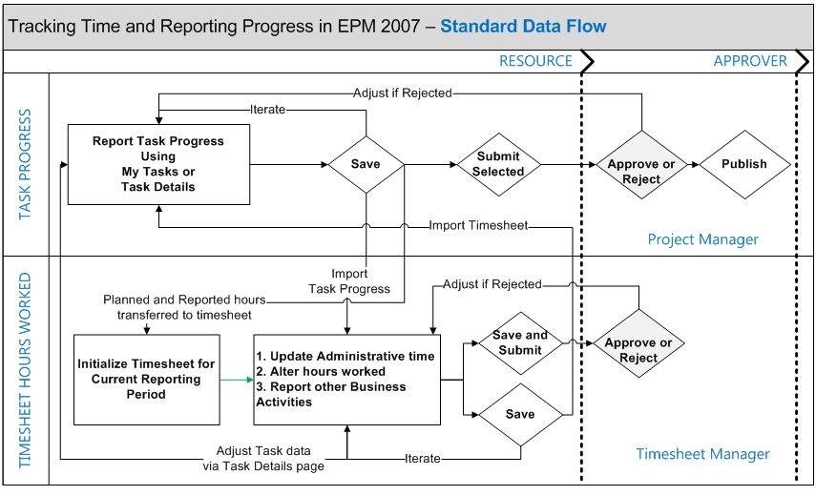

As noted in the diagram, users can report task progress to project managers and timesheet hours worked to timesheet managers separately. However, Project Server 2007 provides the ability to import time entered in one facility to the other so that time entry does not need to be duplicated. There are two general approaches to logging time in Project Server 2007 depending on need for Administrative time recording and approval. Options to be considered include the following:

* Users can log task effort and remaining work estimates in My Tasks, submit these to the project manager and import this time into their timesheet for the period. In the timesheet, the user can complete administrative time entry and submit the timesheet for approval.
* Users can complete their timesheet and submit the timesheet for approval. Once submitted, the user can go to the My Task page and import the timesheet period data in order to update the time recorded on tasks. From the My Tasks page, the user can make task information updates, if needed (e.g., update Remaining Work) and then submit the task data to the Project Manager for project status progressing.

As noted above, you will need to determine the appropriate scenario for time entry, approval and reporting as part of your migration planning.

Project Server 2003 Administrative Plans versus Project Server 2007 Administrative Time

Project Server 2003 administrative projects are migrated as Project Server 2007 administrative projects. Once migrated, these projects operate as standard Project Server 2007 project plans. Therefore, you may wish to use Administrative time categories in Project Server 2007 Timesheets in place of Project Server 2003 Administrative Plans.

Your organization should decide if you want to move to Timesheet reporting of Administrative Time as part of your migration process. If so, you should plan your migration to accommodate the time update and reporting needed for administrative time categories. You should also review Project Server 2007 reporting options for timesheet data (e.g., Data Analysis Reports using the Timesheet cubes) to determine if you can replicate your Project Server 2003 administrative time reports.

Project Server 2003 Historical Time Tracking Data

Project Server 2003 Timesheet historical data is not migrated. However, all status data entered by team members (i.e., hours worked by resources on assignments), will be get migrated. In addition, timesheet periods are migrated. Therefore, if you have a reporting system based on timesheet history, you will need to plan to re-create these reports for the Project Server 2007 database.

Planning For Timesheet Migration

To ensure that the project status information in projects being migrated is accurate and up-to-date, you should have your migration team review all “active” projects (e.g., those that have remaining work balances on resource assignments) and perform the following analysis and actions:

Preparation Steps for Timesheet Migration

| **Analysis Step** | **Action** |
| --- | --- |
| Is the project completed? | A designated Project Manager should perform the following to close out the project.   * Change remaining work to zero on all tasks * Change any relevant project enterprise custom field used for status to a “completed” or “closed” status * Change the resource booking type to “proposed” from “committed”, and lastly * Publish the project. |
| Are the resources on the active assignments active and valid? | A designated Project Manager and/or Resource Manager should ensure that only valid resource assignments exist on active projects. Obsolete resources should be ended (i.e., work zeroed out) or replaced with person or generic resources. |
| Will you be using Timesheets and Timesheet Approval in Project Server following the migration? | The following steps will need to be performed to prepare for timesheet setup and approval in Project Server 2007.   * If Timesheet Approvals will be used, identify the Timesheet Manager for each resource. The Project Server Administrator or Resource Manager should plan on using the Bulk Edit facility in the Resource Center to assign Timesheet Managers to resources after the migration to support timesheet approval processing. * Review your RBS and the Project Server 2007 security group / category permissions for Timesheet review and approval to determine new or updated group and category permissions that need to be made following the migration. * Change remaining work to zero on all completed tasks. |
| Will you be using Project Server 2007 Timesheets with Administrative Time categories to replace Project Server 2003 Administrative Project Plans? | Communications should be made to inform resources to update their administrative time entry through the migration cut-over date. As part of the post-migration process, the Project Server Administrator should configure the Timesheet Settings for this processing:   * Fiscal Periods * Timesheet Periods * Administrative Time categories * Timesheet Reports (Data Analysis and/or custom reports). |

Planning For Reporting Changes and Enhanced Capabilities

Project Web Access views in Project Server 2007 for Project Center (i.e., project summary listings and project details) and Resource Center (i.e., resource listings, resource capacity and resource assignments) are similar to those in Project Server 2007. These views will migrate over “as is” as part of your migration process.

There are enhanced information viewing methods available in Project Professional 2007 and Project Server 2007 that you should be prepared to take advantage of and include in your post-migration activities.

### Project Professional 2007 Visual Reports

A new reporting facility is available in the Project Professional 2007 desktop software that allows the user to extract data from the active project and send that data to either Microsoft Excel or Visio. The Excel extracts will take advantage of the Pivot Table features of Excel for summary reporting and drill-down analysis. The Visio extracts permit visual summaries of data based on field codes or summary project levels. You should review Visual Report capabilities to determine if you should create standard Visual Report templates for your environment and/or allow your Project Professional 2007 users to develop their own analyses using these features.

Project Web Access Data Analysis Views

The number of Online Analytical Processing (OLAP) cubes available for reporting and the level of detail included has been expanded in Project Server 2007. The cubes provide the ability to report on combinations of data for projects, resources, assignments, risks, issues and timesheets. The level of detail has been expanded from what was available in Project Server 2003. For example, project information is available for task level details and time summarization is available for weeks. More information is available in the Project Server SDK on the cube definitions and fields / dimensions available, located at: <http://msdn.microsoft.com/en-us/library/ms512767.aspx>.

SQL Server Reporting Services (SSRS)

SSRS allows you to show customized data extracts formatted to a customized report style needed for information presentation, including graphs and sections. If you are currently using SSRS for reporting in Project Server 2003, you will need to evaluate your current reports and plan time to rewrite the reports for queries against the Project Server 2007 reporting database. The Project Server SDK has a section on the reporting database design and schemas.

There are several other references available for you to see examples of SSRS reports for Project Server 2007 and to get you started in developing these reports, as follows:

* New SQL Reporting Services Sample Reports for Project Server – see <http://blogs.msdn.com/chrisfie/archive/2008/04/10/new-sql-reporting-services-sample-reports-for-project-server.aspx>
* Project Server Extended Report Pack from the Project Conference – see <http://blogs.msdn.com/chrisfie/archive/2007/10/30/project-server-extended-report-pack-from-project-conference.aspx>
* How to create a Milestone Report – see <http://blogs.msdn.com/chrisfie/archive/2008/03/11/how-to-create-a-milestone-report.aspx>.
* Getting at the Task Time Phased Data – see <http://blogs.msdn.com/project_programmability/archive/2007/05/24/getting-at-the-task-time-phased-data.aspx>
* How to track EPM Resource field changes in your Reporting Database – see <http://blogs.msdn.com/chrisfie/archive/2007/10/26/how-to-track-epm-resource-field-changes-in-your-reporting-database.aspx>.

Office SharePoint Server Excel Services

If you are provisioning your Project Server 2007 environment to be operated within a Microsoft Office SharePoint Server environment, they you can take advantage of additional reporting capabilities provided by Excel Services. Excel Services allow you to capture project server data interactively and present it on-demand in the familiar Excel worksheet interface. Excel Services worksheets can include a combination of graphs and data tables to allow real-time reporting and data analysis of your Project Server 2007 statistical and performance data.

References for Excel Services are:

* Configure Excel Calculation Services with Project Server 2007

<http://technet.microsoft.com/en-us/library/cc770224(TechNet.10).aspx>

* New Excel Services Sample Reports for Project Server

<http://blogs.msdn.com/chrisfie/archive/2008/04/13/new-excel-services-sample-reports-for-project-server.aspx>

Planning and Preparing Your Technical Environment

It is important that the minimum requirements are met when addressing hardware and/or software components. Microsoft suggests that additional capabilities are considered for future growth (i.e., additional processors, faster processor speeds, etc.) when planning the system. Microsoft provides detailed information on planning your technical environment for Project Server 2007 in its downloadable book entitled “Planning and Architecture for Office Project Server 2007” which can be found at <http://technet.microsoft.com/en-us/library/cc197331.aspx>.

Verify that computers meet hardware and software requirements

You may choose to perform an “In-Place”upgrade**,** in which case you will need to validate that your existing hardware meets the specifications required to operate Project Server 2007. However, it is common for organizations to plan to migrate to different hardware for their Project Server 2007 implementation. After reviewing and sizing the hardware requirements for your Project Server 2007 implementation (see <http://technet.microsoft.com/en-us/library/cc197379.aspx> for sizing information), you will also need to address the deployment scenarios and options for your migration and continuing operations. In addition to sizing considerations, other questions to consider include:

* Should you deploy your Project Server 2007 and SharePoint Products and Technologies databases on a shared SQL Server database environment?
* How many environments (i.e., instances) do you need for Project Server 2007 and what should they be used for? Production, Staging, Migration Testing, Post-Migration Test / Development Environment, Training?
* Should you share environments on a single set of servers or have different servers? Can any of these environments share resources (e.g., database servers)?
* Should some services that are needed to support peak processing be run on separate servers (e..g., Project Server Reporting Database, SQL Server Reporting Services) be operated on a separate web application server?
* Do you plan to use virtual environments for any of your Project Server 2007 instances? Please review Microsoft articles related to Using SharePoint Products and Technologies in a Hyper-V virtual environment located at: <http://technet.microsoft.com/en-us/library/cc816955.aspx>.
* What level of fault-tolerance do you need for your Project Server 2007 environments? Please see the TechNet article “Planning for fault tolerance and availability in Project Server 2007” which can be found at: <http://technet.microsoft.com/en-us/library/dd162399.aspx>.
* Will you be performing a one-time or gradual migration? What is your time-frame to complete these migrations? If you have a short time window and a significant amount of data to migrate, you may want to see if you can get access to temporary system resources (e.g., database resource pools) to support the large amount of processing needed for the migration tasks.
* What is the usual lead time needed to procure hardware and have it installed with all of the base components needed for a software product installation (e.g., operating system, network monitoring software, security utilities, etc.)? Have you provided for this in your project plan?

Note: It is recommended that you leverage 64 bit architecture for your scale-out scenarios and to prepare for the future release of Project Server which will take advantage of 64 bit technologies. See additional information regarding technology advantages at the following link: [Advantages of Deploying SharePoint Products and Technologies with Windows Server 2008 (Office SharePoint Server 2007)](http://go.microsoft.com/fwlink/?LinkId=116395&clcid=0x409).

Also, see recent articles at <http://technet.microsoft.com/en-us/library/cc262485.aspx> **which state “If server farm performance in a heterogeneous environment becomes an issue, the recommended solution is to migrate all of the SharePoint farm servers to the 64-bit architecture. We highly recommend that you have a migration plan in place to move to a 64-bit only environment as soon as possible. Our support and test data shows that SharePoint products and technologies that are installed on 64-bit servers have significant gains in system throughput and performance during peak loads.” Also see additional information referenced at** <http://blogs.msdn.com/chrisfie/archive/2007/02/02/why-install-x64-version-of-wss-3-0-sharepoint-server-2007-and-sql-2005.aspx>.

Confirm licensing and media

Installation media should be secured with the appropriate licensing as required for the user community. Analysis of licensing requirements should included server licensing (i.e., Windows Server, SQL Server, Office SharePoint Server, Project Server), client access licenses (CAL), and Microsoft Office Project Professional 2007 licenses for those individuals who will be using the desktop application for schedule management. Confirm that you have the media and license keys required prior to starting your installation procedures.

Confirm IT Staffing Availability and Training Needs

You will need experienced IT staff to perform the installation of the hardware and systems software for your Project Server environments. This includes resources who can configure server operating systems, network and security settings, SQL Server database administrators, SharePoint farm administrators and desktop deployment technicians. It is important to identify the specific skills that are needed for your deployment and to secure these resources for the installation with appropriate IT management.

It is extremely helpful for the IT staff to understand the architecture and functionality of Project Server 2007. If your staff has experience with your current Project Server 2003 environment, they will need to understand the differences in the installation and operation of Project Server 2007. At a minimum, the IT staff should read the downloadable book “Deployment for Office Project Server 2007” which is located at: <http://go.microsoft.com/fwlink/?LinkId=79599&clcid=0x409>.

It might also be helpful for some of your staff to attend training, such as IT Professional - Technical Implementation and Configuration of Office Project Server 2007 training course, See the EPM University training course list at: <http://www.epmconnect.com/US/pages/EPMUMicrosoftCourses.aspx> for course content and training course schedules.

There are also several books that are available for use as a reference by your IT staff:

* <http://blogs.msdn.com/chrisfie/archive/2008/06/19/microsoft-project-server-2007-books.aspx>
* <http://blogs.msdn.com/chrisfie/archive/2009/02/12/project-server-2007-book-best-practices-for-implementing-an-epm-solution.aspx>

Install Project Server 2007 Environments

The Deployment Guide for Office Project Server 2007 (see <http://go.microsoft.com/fwlink/?LinkId=79599&clcid=0x409>) outlines the steps for installing your Project Server 2007 Environments. Below are the key steps to follow to prepare your technical environment for Project Server 2007.

Pre-Installation Considerations – Windows Server 2008 (64-bit)

If you plan to install Project Server 2007 onto new servers, it is recommended that you use Windows Server 2008 with 64-bit capabilities (http://technet.microsoft.com/en-us/library/cc531331.aspx). The advantages are outlined in the article referenced at this link: Advantages of Deploying SharePoint Products and Technologies with Windows Server 2008 (Office SharePoint Server 2007) (<http://go.microsoft.com/fwlink/?LinkId=116395&clcid=0x409> )

Installation Prerequisite Steps

1. Install and enable ASP.NET 2.0.50727 in Internet Information Server (IIS).

ASP.NET 2.0 is required for proper functioning of Web content, the Central Administration Web Site, and many other features and functions of Project Server 2007.

1. Install the Microsoft .NET Framework version 3.0.

Go to the Microsoft Download Center Web site at <http://go.microsoft.com/fwlink/?LinkID=72322&clcid=0x409> and on the Microsoft .NET Framework 3.0 Redistributable Package page, follow the instructions for downloading and installing the .NET Framework version 3.0. There are separate downloads for x86-based computers and x64-based computers. Be sure to download and install the appropriate version for your computer.

1. Ensure an SMTP server and a mail client are available.

This is required for user notifications to work. E-mail client is not necessary on the servers. It is a desktop component.

1. Create necessary service accounts and add to appropriate local groups on servers.

These service accounts are all defined in the Project Server 2007 Deployment Guide. Keep in mind that not all accounts need to be unique. Some accounts can be used for multiple roles. Pay careful attention to roles that require elevated security on the servers and which roles should not have any elevated privileges.

Installation Steps

1. Install and configure SQL Server (2005 / 2008) (x64 bit version recommended).

If you will use a new SQL Server instance for your project server, you will need to install the SQL Server software. If you are performing a new installation, it is recommended that you install SQL Server 2008 so that you can take advantage of the new performance and reporting capabilities of this version. The software should be patched to the latest Service Packs.

1. Install and configure Project Server 2007, either Windows SharePoint Services or Office SharePoint Server, and security settings.

For the Project Server installation process, see <http://technet.microsoft.com/en-us/library/cc197479.aspx>. For Windows SharePoint Services or Office SharePoint Server, run the installation wizard, which will guide you through the process. Refer to <http://technet.microsoft.com/en-us/library/cc197479.aspx> for more details. Add the Central Administration site to your trusted sites and configure proxy settings to bypass the local proxy server for local addresses, if required.

Apply all of the latest security updates, Infrastructure Updates and service packs to the software. Read the latest TechNet articles on hotfixes that are available for these software releases and consider applying these hotfixes.

1. Create the web applications.

Configure the web applications to host Project Web Access sites and the Shared Service Provider Administration site. Next, create the Shared Service Provider and the PWA site(s) you will be using for the migration instances.

1. Install the Migration Tool

The Project Server 2007 migration tool needs to be installed form the Project Professional 2007 installation disk. See the Migration Guide for Project Server 2007 for instructions for installing the software (see <http://go.microsoft.com/fwlink/?LinkID=85679>).

Post-Installation Steps

1. Perform Administrative Tasks.

Once the installation is complete, there are several configuration settings that need to be established before the installation is ready to turn over. These include:

1. Configure the incoming / outgoing e-mail settings
2. Set-up and configure the cube building functions for Data Analysis services.
3. Create administrative accounts for users that will require administrative access to Project Server 2007 Server Settings.
4. Communicate final installation information

Details of how and where to access the platform need to be provided to the initial set of users so they can test the platform for readiness for the migration or customization as planned.

Analyzing and Cleansing Your Project Server 2003 Data

Perform Data Analysis to Determine Quality of the Data for Migration

To ensure a smooth migration, existing Project Server 2003 data should be reviewed to eliminate any data corruption and problems with the data. Examples of items to review include: special characters in project names, leading or trailing spaces in enterprise fields, correct values in custom fields, inappropriate or special characters in resource names, duplicate entries, obsolete data, and similar data anomalies. The following sections provide you more detailed information.

**Note:** Microsoft has posted several SQL query tools within the Project Server 2007 Migration document instruction kit. Make sure you familiarize yourself with those tools so you can perform pre-migration analysis.

**Caution:** Successful migration requires that you **not** alter core data, like custom fields, within the enterprise global settings after those fields have been migrated to Project Server 2007. Therefore you must be diligent to determine if your data is clean **before** you actually migrate data from your Project Server 2003 instance to Project Server 2007.

Archive or Delete Project Schedules and Workspaces

Project schedules and associated artifacts that do not need to be ported into the Project Server 2007 environment should be archived or deleted in compliance with the organization's data retention policies. Survey your EPM business user community to discover the following typical data that should not be migrated, which may include:

* Canceled projects that have no relevance for continued access,
* Completed projects that have no remaining work or benefit to be used for historical reference,
* Temporary projects that were for training or experimental purposes,
* Projects that were typically used to collect ongoing system operations or other administrative-type information.

You should also consider the disposition of Windows SharePoint Services workspaces for projects whereby the schedule and resource assignment data is no longer needed. You may have already deleted projects but have retained the associated Windows SharePoint Services workspaces. Consider the following workspace content:

* Artifact documents or records that are needed for continuing customer or product support
* Artifact records required by company policy,
* Any archived data records that are needed by your organization EPM user community.

**Caution:** Windows SharePoint Services workspaces that were created with projects may have been retained even though the schedules have been deleted. These workspaces are not detected nor processed by the Microsoft migration tools. You may need to take special action to migrate these workspaces to your Project Server 2007 installation.

Analyze Project Schedules

Consider running SQL queries to build a complete list of all project schedules stored within the Project Server 2003 repository. Pay particular attention to conditions outlined below:

* Project Server uses some special names to represent the enterprise global project containing the Microsoft Project global configuration settings for your Project Server 2003 instance. These special projects should **not** be altered in any way.
* Identify and delete schedule templates that are not used and/or will not be used within the Project Server 2007 environment. Use the Project Web Access Administration functions to delete unwanted templates.
* Identify project schedules that have been saved into the Project Server 2003 database but have not yet been published. Make sure you determine the reason for this condition and ask project managers if those schedules should be migrated.
* Ensure the enterprise global project has not been left in a checked out state. Make sure you check in the enterprise global before performing migration steps.

**Tip:** You may want to examine the entire project schedule list to be migrated then subdivide the list into smaller segments for actual migration. Example, divide projects by alphabetical name as subsets like: “A thru D”, “E thru H”, or by logical groupings of projects that can be segmented by a specific enterprise project code (e.g. organization). This will allow you to build and execute migration scripts so you can more easily assess migration results and log file content.

Validate Project Server 2003 Configuration Settings and Data

Validate Users and Resources

You should review the Project Web Access user accounts and determine how Project Server 2003 users will be represented within the Project Server 2007 system.

Migration Account

You will create or use a special Windows-authenticated account that is used to perform the migration. This account must have certain SQL and Project Server permissions in order to perform migration steps. Use the following guidelines for this account:

* The account must be a Windows account defined within a Domain that is trusted by the Project Server 2003 and 2007 server machines.
* Add the migration account to the Project Server 2003 Administrators group.
* Add the migration account to the Project Server 2007 Administrators group.
* Add the migration account to a SQL permission group that allows this account to directly read from all of the Project Server 2003 database tables.

PWA Accounts and Enterprise Resource Pool

You should make a list of all PWA users who are listed within the Project Server 2003 system, making sure to include all Active and Inactive resources. You will use this list to validate migration worked as expected. Consider the following analysis and corrective actions:

* Use SQL queries to check for special characters that have known issues during migration. Replace special characters like: semicolon, colon, comma, left and right parenthesis, and math/concatenation/cast operators. These characters can be replaced with the underscore. **Note:** Faulty software automation tools or code are the most common way special characters are accidently included within the enterprise resource pool.
* Determine if any enterprise resource pool entities are missing required enterprise global custom fields. You can use SQL queries or special Resource Center views or filters to review these codes for all resources.
* Examine all enterprise resource pool entities to see if they contain enterprise global custom fields that are not defined within the current enterprise global field definitions.
* **Caution:** This is a rare condition that may have been caused by flawed enterprise global custom field edits in the past.
* **Note:** Use SQL queries to reset malformed enterprise global field settings to NULL if this condition is found.
* Make sure resource names do not contain leading or trailing spaces within the names. Extract the resource names to Excel and use those tools to validate this condition.
* Consider using a special Resource Center view that displays all resources within the Project Server 2003 system, then extract this list to Excel. Then compare that list to a similar list created by using SQL queries. In rare cases the SQL query may reveal inconsistencies from those showing in the Resource Center view.

**Note:** Inactive resources are important because project schedules may have used these resources and accumulated actual work and cost within assignments. You must ensure these resources are included within the migration to ensure schedule data integrity.

Generic and Other Resources

Make sure you also include resources like:

* Generic resources (active and inactive) that represent typical roles.
* Material resources (active and inactive) that are used to represent consumable material within projects.

**Note:** Microsoft Project Professional 2003 users may have used a common workaround to define Material resources as cost tracking resources. Microsoft Project 2007 eliminates the need for this trick by defining Cost resources to serve this purpose. Your resource post-migration activities should include revisions or post-migration conversion for this type of resource condition.

Validate Enterprise Global Custom Fields

You should check the data formation within all enterprise global custom field codes for: projects, resources, and tasks. You need to analyze the codes for conditions like the following:

* Malformed codes with leading or trailing spaces
* Special characters embedded within the field names or values. **Note**: The Descriptions fields can have special characters,
* Possible orphaned fields, abandoned formulas, or abandoned graphic indicators.

**Note:** “Orphaned” enterprise global fields are usually caused when the PWA Administrator removes an enterprise global custom field before clearing all conditions within the project, resources, and tasks. The following symptoms are indicators there may be orphan data fields:

* Project Center and Resource Center views suddenly contain columns that have default names and there is data within some project, task, or resource cell.
* Microsoft Project randomly crashes when opening or saving project schedules.
* Computed formulas and/or graphical indicators are set for enterprise global custom fields that do not have a name.

Validate Security Templates, Groups, Categories

The migration tool automatically protects the names of default Project Server 2007 security Groups in case there are naming conflicts between Project Server 2003 and 2007. You need to examine the names of your Project Server 2003 security groups to determine which, if any, of the default security controls you will use within Project Server 2007. Consider taking the following actions just prior to migrating:

* Rename Project Server 2003 Group, Category, and Template names so they do not conflict with the default names within Project Server 2007.
* Reexamine individual security checkbox settings (Enable/Disable) within each Group to determine desired permissions for the features.
* Examine the individual security checkbox settings within each Category to determine desired permissions for the features.

Validate Security Group and Category Members

Pre-migration is a great time to examine security group role membership to determine who should be placed into or removed from certain security groups. You should examine each and every security group and category, looking for the following:

* Remove everyone except actual application administrators from the Administrators group.
* Remove all individual people from associations with specific Categories. This is a general best-practice whereby you associate Groups to Categories but never associate Categories to individual people. This simple strategy enables you to better manage overall security for defined business roles.

Validate Views and the Associated Security Categories

Project Web Access views are associated with Categories within your security model. The migration is also a great time to examine which PWA views are being used. Consider some cleanup of the active views your organization should use:

* Survey your business owners and responsible managers to determine which PWA views are the most beneficial.
* Consider categorizing the overall Project Center and Resource Center list of views available to people into various Group roles. This makes it easier for people to use the system and also removes certain burden to administer the PWA settings.

Document the Pre-Migration Corrective Action Plan

You may need your project and resource managers to take specific actions to cleanup schedule and resource data before you begin the migration. Consider the following situations as you document the steps needed.

Immediate Actions

* Project managers should accept and post outstanding schedule updates like timesheets or manually entered task progress. This should include rescheduling remaining work as per your regular update cycle requirements. Make sure project managers publish their schedules to incorporate the latest updates.
* Make a list of any project schedules that have caused end-users to witness Microsoft Project Professional 2003 crash incidences. These project schedules probably have serious data problems that should be addressed prior to migration.

Postponed Actions

You may want to postpone certain system changes that you have identified that you would like to implement until after the data has been migrated to Project Server 2007 because the new system has more robust tools that allow you to make those changes. Consider postponing changes like:

* Resource Breakdown Structure (RBS) - these changes are easier to effect with Project Server 2007 tools whereas this type of change requires significant planning and careful execution within Project Server 2003.
* Restructuring enterprise global custom fields - these changes can be tedious within Project Server 2003 edit control functions, whereas these same changes are easily accomplished within Project Server 2007.
* Calendars - Project Server 2007 has more robust resource calendar functions so you may want to postpone this type of change until after the migration.
* Visual Basic for Applications (VBA) – these functions are expanded within Project Server 2007 so you may want to reengineer these programs after migration is complete.

Planning For The Migration Process and Contingencies

There are several steps you should take to plan for a successful migration. In addition, contingency actions should be considered in case specific deliverables are not attained in the expected timeframe, migration issues occur or key resources are unavailable at required times.

Pre-Migration Planning and Documentation Checklist

As noted in previous sections, it is important to plan and schedule the activities require for your migration. This schedule should be communicated to project stakeholders and participants so that the roles and responsibilities for the project activities are known and conflicts with other organizational activities can be discussed.

Pre-Migration Training

It is important to prepare the individuals who will be involved in validating data and verifying the installation in new features and functions of Project Server 2007. At a minimum, Project Managers and other roles who are to be involved in data validation should be trained in the differences in using the Project Professional 2007 desktop and Project Web Access features of Project Server 2007. This includes the ability to open and publish projects, validate resource information, review views and validate permissions for various roles in your migrated instance.

Pre-Migration Checklist

It is important to gather and document the following information about your environment:

Server Information

List the configuration names and URLs for the servers being used for your migration.

Project Server Information

| **Description** | **Configuration Details** |
| --- | --- |
| Project Server 2003 application server |  |
| Project Server 2003 application server domain membership |  |
| Project Server 2003 instance |  |
| Project Server 2003 SQL server |  |
| Project Server 2007 application server |  |
| Project Server 2007 application server domain |  |
| Project Server 2007 instance |  |
| Project Server 2007 SQL server |  |

Database Information

Verify the following information related to the databases involved in the migration

Databases Information

| **Description** | **Configuration Details** |
| --- | --- |
| Project Server 2003 database |  |
| Project Server 2003 database backup file |  |
| Project Server 2007 published database |  |
| Project Server 2007 draft database |  |
| Project Server 2007 archive database |  |
| Project Server 2007 reporting database |  |

Migration Account Verification Information

A Windows domain account with Project Server administrative privileges is required in order to run the migration tool. Verify the following requirements:

Migration Account Verification

| **Description** | **Details** |
| --- | --- |
| Windows ID used for migration |  |
| Domain membership |  |
| Verify membership of Administrators Group in Project Server 2003 | Yes / No |
| Verify membership of Administrators Group in Project Server 2007 | Yes / No |
| Membership of Administrators group in Project Server 2007 application server | Yes / No |
| Verify READ permission for Project Server 2003 database | Yes / No |

Migration Tool and Project Server 2007 Version Verification

Verify the location and version installation pre-requisites for the migration.

Migration Tool and Project Server 2007 Version Verification

| **Description** | **Details** |
| --- | --- |
| Migration Tool location folder | x:\Program Files\Microsoft Office\Office12\ |
| Verify install of Service Pack 1 for Project Server 2007 | Yes |
| Verify install of Service Pack 1 for Project Professional 2007 | Yes |

Perform data analysis on your existing Project Server 2003 data.

Run a Pre-Migration Verification Test

The migration tool provided by Microsoft allows you to run the migration process with a pre-migration verification test to identify potential data issues.

The steps required to run a migration test are as follows:

1. Create Full Backup of Project Server 2003 database
2. Copy Backup file to the Migration SQL Server Database Server
3. Restore the Project Server 2003 database to the Migration SQL Server Database with the designated name
4. Run migration tool in a command window as follows:

* x:\Program Files\Microsoft Office\OFFICE12>P12MigrationTool.exe -c
* x:\Program Files\Microsoft Office\OFFICE12\CHECK.INI” –verify

1. Review migration log MIGRATION_CHECK file for errors.

**Note:** The migration tool’s  **-verify**  option will examine your Project Server 2003 data for the following data conditions:

* Projects that are checked out
* Projects that have been modified externally
* Projects with pending status updates
* Duplicate enterprise resources

These data conditions will need to be corrected prior to the final migration. See the Project Server 2007 Migration Guide for the steps required to resolve these issues.

Data Analysis Queries and Corrective Actions

In addition, there are several other tests you can run to help you analyze your data prior to performing a migration (see the Migration Guide for descriptions and source code examples of the queries). Below is a list of these Queries and a table for recording the results.

Project Server 2003 Data Verification

| **Query** | **Result** |
| --- | --- |
| Enterprise Global Template Externally Edited Check |  |
| Enterprise Global Template Checked-Out Check |  |
| Enterprise Global Template Not Locked Check |  |
| Special Characters in Resource Names Audit |  |
| Required Resource Custom Fields without Values |  |
| Resource Custom Field Values NOT in Lookup Table |  |
| Externally Edited Resources |  |

The corrective actions for these data conditions are outlined in the Migration Guide.

More information can be found on Pre-migration verification and clean-up at the following TechNet article: <http://technet.microsoft.com/en-us/library/cc197599.aspx>.

Contingency Planning

Once you perform your pre-migration verification and data analysis, you will need to estimate the amount of effort required to clean-up your data to ensure a successful migration. If the effort and coordination required to perform these activities is large, you may need to make alternative plans for the approach for your migration. Some of the contingencies to plan for are the following:

* Change the migration approach from a full migration to a gradual migration.
* Identify a subset of projects that must be migrated as part of the first wave of migration because they are actively being worked. Assign tasks for data clean-up to these projects and associated resource records first.
* Identify a short-period of focused time for resources to clean-up project and resource data.
* Plan recurring dates to re-run the Verification process and data analysis tests to provide updates for project sponsors on the progress of the data cleansing activities.
* Talk to project sponsors regarding the impact of the data issues to the migration schedule and resource requirements for data clean-up. Alternatively, talk about options for using the gradual migration strategy.
* Scale back plans for use of Project Server 2007 features to help minimize the amount of effort needed for migration and post-migration activities.

Perform a Test Migration

Once you have sufficiently cleaned up the Project Server 2003 data that will support your planned configuration and business processes, it is recommended that you run a test migration into your planned Production Migration environment. The objectives of a test migration are to:

* Validate and document the set-up procedures for the migration.
* Verify that the pre-migration data cleanup has provided the expected results and has not adversely impacted the migration process. This includes changes to the security model, lookup tables and/or deletion of obsolete resources and custom fields.
* Identify the amount of time required to perform the migration process.
* Identify and document the post-migration steps that need to be performed to prepare the Project Server 2007 environment for operations.
* Identify any migration process or data issues that need to be resolved prior to the migration production cut-over.
* Validate the grouping of projects identified for gradual and/or batched project plan migrations for the migration process.
* Validate the training and business process documentation created for using Project Server 2007.
* Test and validate the systems performance on the new Project Server 2007 instance.

The key deliverables from the Test Migration are the pre and post-migration checklists that will be used to perform and validate the completion of migration steps during the migration process.

Once the Test Migration is completed and verification steps are finalized, your organization should make a go / no-go decision to proceed with the migration.

Performing the Migration and Post-Migration Activities

The migration process has three stages: Pre-Migration, Migration and Post-Migration.

Pre-Migration

If you have followed the business process analysis steps previously outlined in this guide, you will have identified changes you need or would like to make to your application configuration so that you are ready to use new features or business processes immediately following the migration. In addition, there are pre-migration steps that can be performed to minimize the amount of data maintenance needed after the migration process is performed.

Update the Enterprise Global file to reflect new objectives and processes

You should make the effort prior to the migration to modify/replace existing Enterprise fields with changes and/or improvements as necessary (i.e. updated Lookup Tables, Values, and Formulas).

Refer to the Project Server 2007 Migration Guide, <http://technet.microsoft.com/en-us/library/cc197505.aspx> for extensive information on business configuration details.

Update or Re-engineer the RBS

Identify required changes to be made to the RBS prior to migration in order to simplify the overall migration process and/or to allow you to take advantage of some of the new features of Project Server 2007 that may be managed or controlled by Category security and the RBS. For more information, go to <http://technet.microsoft.com/en-us/library/cc197505.aspx>.

Update or Re-engineer User Access and the Project Security Model

As noted earlier, you may decide to update the security model in the existing Project Server 2003 Database before migrating to Project Server 2007 Production to make necessary changes needed for post-migration usage. At a minimum, your should rename Project Server 2003 Group, Category, and Template names so they do not conflict with the default names within Project Server 2007. Once migrated, the updated Project Server 2003 security templates will be updated to accommodate Project Server 2007 functionality and utilized in the Project Server 2007 EPM environment. The default Project Server 2007 security templates; however, will be retained for backup, support, and testing purposes.

For more information, go to <http://technet.microsoft.com/en-us/library/cc197505.aspx>.

Perform a final Project Server 2003 data clean-up, verification and backup

Prior to migration of the data, make sure that all data to be migrated has been reviewed and corrected, if in error. Check in all projects, update and approve all tasks, and ensure that nothing is in a pending status. Make sure that all completed or cancelled projects have no remaining work and that all tasks are marked as 100% complete.

If projects have been externally edited (updated by custom integration with external systems), a flag is set in tables in the database by the external systems so that when Project Professional opens the project it knows to reprocess the project to incorporate any external edits. These projects must be saved back to the database prior to saving your Project Server 2003 database “snapshot” for migration.

Projects need to be 'clean' (up to date) before migrating them to Project Server 2007. Here are the suggested steps for the final data clean-up.

1. Run the SQL cleanup queries defined above to verify all critical data conditions have been resolved.
2. Delete obsolete Enterprise Custom Fields and associated Outline codes from the Project Server 2003 database.
3. Complete all remaining corrections identified in the data migration requirements.
4. Prepare your lists of projects to be migrated in “waves” and put them into a .txt file for use in the migration scripts.
5. Ensure that all projects with links to other projects are listed as last to be migrated.
6. Ensure that the Enterprise Global is not locked or checked out.
7. Lock-out users from your Project Server 2003 instance.
8. Run the OLAP cube.
9. Backup your Project Server 2003 database.

Perform a final Windows SharePoint Services data clean-up, verification and backup

The following steps should be performed prior to starting the migration of the Project Work Spaces.

1. Review Windows SharePoint Services workspaces for obsolete or unused content. Delete obsolete or unused workspaces
2. Verify that Project Server 2003 Windows SharePoint Services Content database has been upgraded to Service Pack 2a. Run the Prescan utility provided by Microsoft for this verification.
3. Lock-out users from your Project Server 2003 instance
4. Backup your Windows SharePoint Services Content database.
5. Upgrade the Project Server 2003 Windows SharePoint Services Content database from Windows SharePoint Services version 2.0 to version 3.0 using the stsadm addcontentdb command (see the TechNet article Upgrading project workspaces from Project Server 2003 at <http://technet.microsoft.com/en-us/library/cc197564.aspx> for specific instructions).
6. Add the upgraded Windows SharePoint Services content database to the Project Server 2007 in preparation for the migration process.

Migration

It is recommended that you run your migration process in multiple steps, with verification checks at each step, to enable an orderly and successful migration.

Prepare for the Migration

1. Verify that the Project Server 2007 databases are empty.
2. Backup the Project Server 2007 databases (i.e., Published, Draft, Reporting and Archive databases).
3. Restore the Project Server 2003 database to be used for the migration to the Project Server 2007 environment.
4. Restore or confirm the restore of the upgraded Windows SharePoint Services content database to the Project Server 2007 database environment.

Enterprise Global Data Migration

1. Configure the **Migration**.INI file to migrate Enterprise Global Data, PWA Views and Enterprise Global Resources. **Note:**  We recommend you establish a naming convention for each of the **Migration**.Ini configuration files used for your migration process
2. Run the file for the Enterprise Global Migration, as follows:

x:\Program Files\Microsoft Office\OFFICE12>P12MigrationTool.exe –c “x:\Program Files\Microsoft Office\OFFICE12\**Enterprise-Global-Migration**.ini”

Note: This **Enterprise-Global-Migration**.ini file name would contain the parameters to migrate the Enterprise Global parameters, PWA Views and all resources in the Resource Pool to the Project Server 2007 instance.

1. Review the migration log for the file for any errors with Enterprise data and apply fixes, if needed. Also, verify the Project Server 2003 global data in Project Server 2007 (i.e., global settings, PWA Views, Enterprise Resources).
2. Perform a detailed analysis of the Enterprise Global Data migrated into your Project Server 2007 instance before proceeding to the next step – Project Data Migration.

Things to check as part of your Enterprise Global post-migration validation include:

Resources

* Check resources for the default assignment owner, which should be the resource itself.
* Check resource attributes
* Verify workgroup setting, RBS, Booking Type, Timesheet Manager

Enterprise Custom Fields

* Verify if custom code definitions match the ones defined in Project Server 2003.
* Verify if value list definitions match the ones defined in Project Server 2003 outline codes values.

Enterprise Calendars

* Verify if Enterprise Calendars definition matches the one defined in Project Server 2003.

Project Data Migration

1. Configure the project data **Project-List-Migration**.INI file to migrate your selected projects for the migration. Consider your options for the selected projects by setting the appropriate **Project-List-Migration**.ini file parameters, including

* Determining whether to stop the migration if Projects have Status Pending Updates
* Determining whether to Save or Save and Publish your projects after migration
* Determining whether to publish Master Projects after the migration
* Explicitly listing projects to be excluded from the migration

1. Test run the migration utility with the **–verify**  option enabled and check for errors in the log
2. Run the file for the Project Migration, as follows

x:\Program Files\Microsoft Office\OFFICE12>P12MigrationTool.exe –c “x:\Program Files\Microsoft Office\OFFICE12\**Project-List-Migration**.ini”

Note: This **Project-List-Migration**.ini file name above would contain the specific projects to be migrated.

1. Review the migration log to determine if any projects failed to migrate. Make corrections and re-run, as required.
2. Verify the migrated projects by checking key data like project start / finish dates, total work, total costs, total number of tasks etc. See the Post-Migration section below for a more comprehensive list of data validation steps.
3. Verify that Windows SharePoint Services linked to their respective projects

Roll back Migration

You may want to rollback the migration should one of the following occur:

* The migration fails in the middle of the process.
* Changes have continued to be made to the Project Server 2003 instance following the migration and you need to re-do the migration to capture these changes.

Post-Migration

Once the data has been migrated and validated, you are ready to finalize the setup for production use. Some of the key steps to be performed are as follows:

1. Verify whether the migration worked. Things to check as part of your Enterprise Global post-migration validation include:

Projects – Using Project Web Access

* Check if total number of projects and aggregate totals of values in views agree with Project Server 2003 (Note: If you performed a partial migration, you should create a view in Project Server 2003 that will allow you to validate the selected projects that you have migrated).
* Verify if Project Web Access custom views from Project Server 2003 are working properly in Project Web Access 2007.

Projects – Using Project Professional

* Use Project Professional 2007 to create a project and verify its publication.
* Check that project data is valid and that normal project operations can be performed (e.g., build team, add resources, publish projects, status updates accepted, etc.).

1. Update migrated server settings as needed. Things to consider for post-migration changes include:

* Merging / renaming similar security groups, categories, templates
* Set new permissions from the migrated permissions and migrate existing categories to new Project Server 2007 categories.
* Updating, renaming or creating new view definitions
* Update the OLAP cube configuration for enhanced data analysis reporting.

1. Synchronize the migrated forms-authenticated users with the Project Server 2007 forms authentication store
2. Verify the project workspace provisioning settings
3. Delete migrated inactive users if not performed during pre-migration.
4. Fix project currency settings.
5. Change migrated local Windows accounts
6. Update multi-language lookup tables, where applicable.
7. Consider running the Project Server 2007 Migration Rename Tool for your Project Server 2003 projects that have "_Published" appended at the end of their name. This tool enables you to "bulk" rename all projects and remove the "_Published" string from all project names. It can be found at: <http://code.msdn.microsoft.com/PS2007Rename>

Perform a final validation that migration is complete and all data has been accurately updated in the new Project Server 2007 environment. Settings, permissions, calendars, formulas, views, resources, currency, and reports should all be validated as well as appropriate access testing for each type of user who is set up in the system. Modifications should be made as appropriate prior to transition to full-use operations.

You should also send out communications e-mails to appropriate users and leadership team members to inform these stakeholders that the migration has been completed and to inform them of the appropriates URLs and procedures for logging into the new Project Server 2007 environment.

Preparing for Changes to Technical and Business Operational Policies

A successful Project Server 2007 migration project should prepare your organization for the changes to technical and business operations that will be required to keep your systems functioning well with business information that allows you effectively manage your projects and resources.

Project Server Technical Operations and Maintenance

It is important to establish a regular routine to protect your information, review your systems to maintain optimal performance and to identify issues that are or could impact end user activities. Microsoft has provided resources on TechNet for Operations for Project Server 2007, many of which are described in this section. Please see <http://technet.microsoft.com/en-us/library/cc197578.aspx> for details on the key components to Project Server 2007 operations strategy.

Protecting Your Information Assets

You should determine the criticality of the information you will be retaining in Project Server and the appropriate system backup and retention schedules needed for business continuity planning.

There are several Microsoft technologies to consider for your backups:

* Microsoft Project Server 2007 built-in tools
* SQL Server tools
* Central Administration farm tools

For a comprehensive discussion of steps to be taken to protect and restore the Project Server 2007 environment, please see the TechNet articles at: <http://technet.microsoft.com/en-us/library/cc706826.aspx>.

Included is an enterprise disaster recovery plan for Project Server 2007 at: <http://technet.microsoft.com/en-us/library/dd277856.aspx> which discusses how best to prepare your backup strategy for SharePoint Products and Technologies and SQL Server technologies to ensure full recovery of your Project Server environment.

Technical Operations and Maintenance Schedule

It is recommended that you establish daily, weekly, monthly and annual routines for Project Server 2007 Operations and Maintenance

Daily Activities Checklist

This checklist provides a high-level list of major necessary steps required to complete daily routine maintenance activities. The steps do not need to be performed in any particular order.

Daily Activities Checklist

| # | Step | Comments |
| --- | --- | --- |
| **1** | Verify nightly jobs successfully ran: This should include the Project Server and associated databases nightly database backups. | SQL DBA to complete. This must be checked from SQL Server. |
| **2** | Examine the Project Server Queue via Server Settings > Manage Queue. If jobs have not been processed and get stuck, resulting in incomplete processes, try the function again. If the process is stuck because the job is not cancelling properly, select Advanced Options, check the “Cancel jobs getting enqueued” (see below) and cancel the jobs.    Note that this should be done sparingly, and only if the jobs that are enqueued are jeopardizing other processes.  For more information on cleaning up the queue, see <http://blogs.msdn.com/brismith/archive/2007/11/02/friends-don-t-let-friends-delete-their-cache-or-cancel-queue-jobs.aspx>  Also see the following blog for more troubleshooting techniques.  <http://blogs.msdn.com/chrisfie/archive/2007/04/17/troubleshooting-epm-2007-queue-issues.aspx>  Refer to the Queue Management document at Technet for more information on the queue:  <http://technet2.microsoft.com/Office/en-us/library/91c0c38a-51e1-4aaa-a675-a8d56cd5f08a1033.mspx?mfr=true> | Technical Project Server Administrator |
| **3** | Use MOM (Microsoft Operations Manager) if your organization has it for proactive monitoring-items such as cube build failure, large number of queue job failures, project plans taking a long time to open etc. You may use MOM once it is set up rather than monitoring all the jobs in the queue. | Technical Project Server Administrator to complete |
| **4** | Examine Project Server machine application and security event logs for the following types of errors: Active Directory, IIS, Windows SharePoint Services, Project Server events. If you need more information about particular events, review the trace log at:  C:\Program Files\Common Files\Microsoft Shared\Web Server Extensions\12\Logs | Technical Project Server Administrator to complete |
| **5** | Examine SQL Server machine application and security event logs for the following types of errors: SQL Server and Analysis Services | Someone with privileges to log onto the SQL Server machine can complete (i.e. DBA) |
| **6** | Ensure OLAP cube built successfully and Data Analyzer views are functioning correctly | Project Server Administrator to complete |
| **7** | Move inactive projects to Inactive Projects category if appropriate. | Project Server Administrator to complete |
| **8** | Run Data Base backup sets (for Draft and Published databases in Server Settings) using automatic backup settings. | Technical Project Server Administrator to complete |
| **9** | Run differential Central Administration farm backup. | Technical Project Server Administrator to complete |
| **10** | Run SQL backups nightly. | Technical Project Server Administrator to complete |

Weekly Activities Checklist

This checklist provides a high-level list of major necessary steps required to complete weekly routine maintenance activities. The steps do not need to be performed in any particular order.

Weekly Activities Checklist

| # | Step | Comments |
| --- | --- | --- |
| **1** | Ensure weekly integrity checks have run in the database maintenance plan. See the following URL for more on maintenance tasks:  <http://blogs.msdn.com/chrisfie/archive/2007/10/25/epm-database-maintenance-tasks.aspx>. | SQL Server DBA to complete. |
| **2** | Review performance thresholds (in MOM or using the Perfmon project server counters)  See the following Blog entry on performance counters  <http://blogs.msdn.com/chrisfie/archive/2007/10/08/epm-sharepoint-performance-counters.aspx> | Technical Project Server Administrator |
| **3** | Review list of checked out projects or other Project Server objects. Do not check in automatically, but check with PM or owner to see if the items should be checked in.. | Technical Project Server Administrator to complete |

Monthly Activities Checklist

This checklist provides a high-level list of major necessary steps required to complete monthly routine maintenance activities. The steps do not need to be performed in any particular order.

Monthly Activities Checklist

| # | Step | Comments |
| --- | --- | --- |
| **1** | Reboot Project Server and its related components. | Server Administrator to complete. |
| **2** | Ensure Unused Space from the Database Files is selected in the Optimization portion of the database maintenance plan. | SQLServer DBA to complete |
| **3** | Run Smoke Test Utility to test basic functionality and performance timings. Compare these results with the baseline originally captured. (Note: It is recommended that you keep key results in a spreadsheet for comparison and trend analysis). | Technical Project Server Administrator to complete |
| **4** | Review performance against baselines. | Technical Project Server Administrator to complete |
| **5** | Check for new documents on the TechNet site. | Technical Project Server Administrator to complete |
| **6** | Run the Best Practices Analyzer (check to see if there are new versions available) | Technical Project Server Administrator to complete |
| **7** | Update operations and maintenance documentation. | Technical Project Server Administrator to complete |
| **8** | Review hotfixes and service pack updates for both Windows SharePoint Services and Project Server for upcoming decisions about implementing them. | Technical Project Server Administrator to complete |
| **9** | Maintain and update your Disaster Recovery processes and supporting documentation. | Technical Project Server Administrator to complete |
| **10** | Review permissions settings and selections. Clean up any unnecessary groups, users associated with specific categories, etc. Keeping permissions simple and fixing issues early will help prevent long-term maintenance issues. | Technical Project Server Administrator to complete |

Annual Activities Checklist

This checklist provides a high-level list of major necessary steps required to complete annual routine maintenance activities. The steps do not need to be performed in any particular order.

Annual Activities Checklist

| # | Step | Comments |
| --- | --- | --- |
| **1** | Archive project plans that are no longer needed for operations or historical reporting (see the Archiving and Data Retention Policies section below) | Technical Project Server Administrator to complete |
| **2** | Test your Disaster Recovery processes and update your supporting documentation. | Technical Project Server Administrator to complete |

Project Server Applications Operations and Maintenance

It is important for the Project Server Applications administrator to establish processes and routines to support Project Server users and capture / implement changes imposed by the business to the Project Server application configuration. You should restrict Project Server administration functions to trained users who understand the consequences that changes will have on users and data.

If your organization has a trouble ticket or issue management system, you should consider adding Project Server to the list of applications where issues are captured and routed for resolution. Alternatively, you should consider using an Issues Tracking list web part on your top-level Project Web Access site for users to submit issues and monitor their resolution.

As with issue resolution, to support requests for changes to the application configuration, consider establishing a facility to capture and prioritize requests from users. This can be done with a Task or Change Request list web part on your top-level Project Web Access or via your organization’s trouble ticket application. Below are the common Project Server maintenance areas:

Security

Once you have migrated the users from your Project Server 2003 system and verified their permissions, there will be a number of activities that need to be performed to keep your user access current and accurate. Security roles will identify who can perform security maintenance functions. This includes:

Adding Users – users can be added via the Resource Center, Manage Users function in Server Settings or via Active Directory Synchronization.

Manage Users – this includes changing their login information, team assignments and resource custom fields, including the RBS. Changes to RBS may impact what the user can see and perform on the system, depending on your security model.

Manage Security Group and Category Permissions – as you become familiar with the new features available in Project Server 2007, you may need to add or change your security groups and category permissions to accommodate the changes in your business rules or processes or to provide / restrict access to existing users to specific features.

Enterprise Data

You may need to change or add to the Enterprise Custom Fields that you have migrated from your Project Server 2003 instance to accommodate usage or reporting requirements. You may have been restricted by the number of fields that you were allowed to have in your Project Server 2003 implementation. Project Server 2007 allows an unlimited number of fields for each data type, so you might want to add additional fields or implement enterprise fields where you had previously used local fields in your Microsoft Project schedules. You should evaluate requests to change these Custom Fields based on the impact to business process and views / reports that need to be updated to accommodate these changes. Changes to enterprise data include:

* Adding Enterprise Custom Fields
* Changing Lookup tables for existing custom fields
* Updating or Changing formulas in custom fields with calculations

When changing existing fields, please be aware of the impact to historical data and reports that are used for comparative purposes.

Enterprise Global

Your Enterprise Global file is part of Project Professional 2007 and is used to standardize the user interface features, views, and scheduling calculation options that your project schedulers will use. You should use your change control process to manage requests and changes to the Enterprise Global.

Timesheet Management

If your organization is using Project Server Timesheets, you will need to maintain settings in the Time and Task Management section of Server Settings. Specifically, you will need to

* Set-up and adjust fiscal year preferences and settings – for fiscal period reporting of timesheet data.
* Create Timesheet Reporting Periods – using the Bulk Timesheet Period creation tool with prefixes and suffixes for your period names to enable easy identification.
* Open and Close Timesheet Reporting Periods - based on your business rules for when users should be able to report and approve timesheets.
* Add or Disable Timesheet Classifications types - for recording non-project related activities on project assignments
* Add or Disable Administrative Time Categories – for recording administrative working and non-working time (e.g., Paid-Time-Off (PTO)) using the timesheet.

Reporting

There are several types of reporting available for Project Server 2007 and steps to consider after you have completed your migration.

Reporting - Managing Views

Project Server Administrators will often find that they will spend a lot of time updating the Look and Feel of Project Server 2007 after a migration. End Users will often request additional customized views or changes to existing views in order to replace the filtered views that they had with the Save Link feature in Project Server 2003. Also, if an organization has decided to take advantage of new features in Project Server 2007 (e.g., Team Resources), they often need additional views created to help them view the data associated with the feature. In addition, the expanded list of fields and cubes available in the On-Line Analytical Processing (OLAP) cube databases can initiate requests for additional or expanded Data Analysis views.

Reporting – Managing the OLAP Cube

Once you have migrated to Project Server 2007, you should decide on the frequency of update and range of data you wish to have available in your On-Line Analytical Processing (OLAP) cube for Data Analysis reporting. Most organizations will want to process their OLAP cube during the off-hours to minimize the impact on systems performance. While it is true that the performance impact is less severe than with Project Server 2003 because of the separate Reporting database in Project Server 2007, you will still want to consider the impact on overall database processing performance for your cube build kick-off time. In addition, you should consider the appropriate date range for your OLAP records that is required for your reporting needs.

Reporting – SQL Server Reporting Services (SSRS)

If you have implemented SSRS with your Project Server 2007 implementation, you will want to establish change management procedures for requesting and deploying reports within your environment.

Database Object Administration

Project Server 2007 provides the ability to delete enterprise objects, such as projects and their associated project workspaces, resources, timesheets, status reports, etc. Deleting these objects can have serious consequences on your Project Server data. Establish policies and/or approval processes for deleting data from your Project Server environment along with your data retention polices.

Archiving Projects and Data Retention Policies

As noted above, Microsoft Project Serer 2007 has built-in tools that provide the capability to back-up individual items and store them in the Archive database. This capability allows Project Server administrators to quickly restore projects without having to restore the entire database. These backups can be performed manually or scheduled to run periodically using the Daily Backup Schedule option in the Database Administration section of Server Settings. You should determine what your Data Retention Policy should be for your project schedules.

The main reason to archive is to restore any accidentally deleted items directly from the Archive database if needed through Administrative Restore feature. Archiving is also used to free space in the Published and Draft databases by deleting the project in these databases after the project has been backed up to the Archive database. You should determine the frequency with which you need to perform these backups, how often you need to perform these, what time of day they should be scheduled and how many historical versions of projects that you need to maintain. Please note that the growth and size of your Archive database will be based on these settings, especially with regards to Projects.

Your Project archiving strategy should plan for archiving of project workspaces that are associated with the Projects. In addition to removing the project schedule from the Published and Draft databases, consider deleting the project workspace from the active Windows SharePoint Services Content database associated with Project Server if the data and artifacts are no longer needed. If you decide to use the Archive database for archiving project schedules, note that the Archive database does not allow for archiving of project workspaces. The rules for workspaces and schedules should be developed in a similar fashion, but the method for archiving is different for both. Please consult with your SharePoint administrator on options for backing up your Project Workspaces.

Once a project and workspace have been archived, standard reporting will not be available. This is because both the project will have been deleted out of the Published and Draft databases and the workspace deleted from the Windows SharePoint Services content database. However, SQL Server Reporting Services can be used to report on project information in the Archive database.

Please note that you do not have to remove projects that are archived if you need the data for historical reporting purposes. Instead, you may choose to use an enterprise field to categorize a project as “inactive,” These projects may stay in the active databases (as defined by your organization’s specific project retention rules) and can be filtered from active project views and reports. However, the growth and size of your project server databases can impact performance. So you should consider the most optimal period of data required for on-going operations and historical reporting.

Archiving Other Database Objects

As with projects, you can quickly restore other items, such as resources, views, without having to restore the entire database. These backups can be performed manually or scheduled to run periodically using the Daily Backup Schedule option in the Database Administration section of Server Settings. You should determine how often to perform and archive of the other Project Server 2007 database objects listed below:

* Enterprise Resource Pool and Calendars
* Enterprise Custom Fields
* Enterprise Global
* View Definitions
* System Settings
* Category and Group Security Settings

Project Server 2007 7can retain one archive copy of each object.